Challenge, Equality & Opportunity
Number & Place Value | Addition & Subtraction | Multiplication &  Division | Fractions
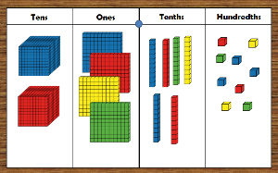 | 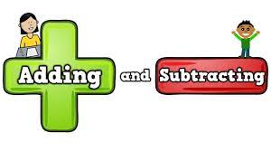 | 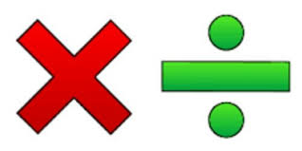 | 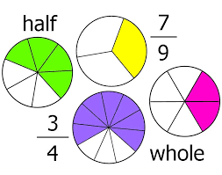
Measurement | Geometry - Shape | Geometry - Position & Direction | Statistics
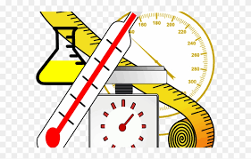 | 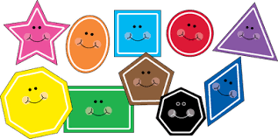 | 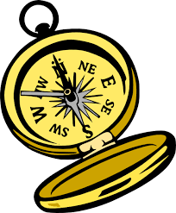

Challenge, Equality & Opportunity
Reception
 | Week 1 | Week 2 | Week 3 | Week 4 | Week 5 | Week 6 | Week 7 | Week 8 | Week 9 | Week 10 | Week 11 | Week 12
Autumn | Getting to Know You  Opportunities for settling in, introducing the areas of provision and getting to know the children.  Key times of day, class routines. Exploring the continuous provision inside and out. Where do things belong?  Positional language |  |  | Just like me! |  |  | It’s Me 1, 2, 3! |  |  | Light and Dark |  |  | Phase
 |  |  |  | Match and Sort  Compare Amounts |  |  | Representing 1,2 &3  Comparing 1,2 & 3  Composition of 1,2 & 3 |  |  | Representing Numbers to 5  One More and Less |  |  | Number
 |  |  |  | Compare Size,  Mass & Capacity  Exploring Pattern |  |  | Circles and Triangles  Positional Language |  |  | Shapes with 4 Sides  Time |  |  | Measure, Shape and Spatial Thinking
Spring | Alive in 5 |  |  | Growing 6,7,8 |  |  | Building 9 & 10 |  |  | Consolidation |  |  | Phase
 | Introducing zero  Comparing numbers to 5  Composition of 4 & 5 |  |  | 6, 7 & 8  Combining 2 amounts  Making pairs |  |  | Counting to 9 & 10  Comparing numbers to 10  Bonds to 10 |  |  |  |  |  | Number
 | Compare Mass (2)  Compare Capacity (2) |  |  | Length & Height  Time |  |  | 3d-shapes  Patterns |  |  |  |  |  | Measure, Shape and Spatial Thinking
Summer | To 20 and Beyond |  |  | First Then Now |  |  | Find my Pattern |  |  | On the Move |  |  | Phase
 | Building Numbers Beyond 10  Counting Patterns Beyond 10 |  |  | Adding More  Taking Away |  |  | Doubling  Sharing & Grouping  Even & Odd |  |  | Deepening Understanding  Patterns and Relationships |  |  | Number
 | Spatial Reasoning (1)  Match, Rotate, Manipulate |  |  | Spatial Reasoning (2)  Compose and Decompose |  |  | Spatial Reasoning (3)  Visualise and Build |  |  | Spatial Reasoning (4)  Mapping |  |  | Measure, Shape and Spatial Thinking

Challenge, Equality & Opportunity
YEAR 1
 | Week 1 |  | Week 2 | Week 3 |  | Week 4 | Week 5 |  |  | Week 6 | Week 7 | Week 8 |  | Week 9 | Week 10 | Week 11 | Week 12
Autumn | Number: Place Value – Within 10 |  |  |  |  |  |  |  | Number: Addition & Subtraction – within 10 |  |  |  |  |  |  | Geometry: Shape | Consolidation  Assessment
Spring | Number: Place Value  (within 20) |  |  |  | Number: Addition & Subtraction- (within 20) |  |  |  |  |  | Number: Place Value (within 50) |  | Measurement: Length and Height |  |  | Measurement: Weight and Volume |  | Assessment
Summer | Consolidation | Number: Multiplication and Division  (Reinforce multiples of 2, 5 and 10 included) |  |  |  |  |  | Number: Fractions |  |  | Geometry: Position & Direction | Number: Place Value  (within 100) |  |  | Measurement: Money | Measurement: Time |  | Assessment

Challenge, Equality & Opportunity
YEAR 2
 | Week 1 | Week 2 | Week 3 | Week 4 | Week 5 | Week 6 | Week 7 | Week 8 | Week 9 | Week 10 | Week 11 | Week 12
Autumn | Number: Place Value |  |  |  | Number: Addition & Subtraction |  |  |  |  | Geometry: Properties of Shape |  |  | Assessment
Spring | Measurement: Money |  | Number: Multiplication and Division |  |  |  |  | Measurement: Length and Height |  | Measurement: Mass, Capacity and Temperature |  |  | Consolidation  Assessment
Summer | Statistics |  | Number: Fractions |  |  | Problem Solving |  | Geometry:  Position and Direction |  | Measurement: Time |  |  | Assessment

Challenge, Equality & Opportunity
YEAR 3
 | Week 1 | Week 2 | Week 3 |  | Week 4 | Week 5 |  | Week 6 | Week 7 | Week 8 |  | Week 9 | Week 10 |  | Week 11 | Week 12
Autumn | Number: Place Value |  |  |  | Number: Addition & Subtraction |  |  |  |  |  |  | Number: Multiplication and Division |  |  |  |  | Consolidation Assessment
Spring | Number: Multiplication and Division |  |  |  | Measurement: Length and Perimeter |  |  |  | Number: Fractions |  |  |  |  | Measurement: Mass and Capacity |  |  | Consolidation  Assessment
Summer | Number: Fractions |  |  | Measurement: Money |  |  | Measurement: Time |  |  |  | Geometry: Properties of Shape |  |  | Statistics |  |  | Consolidation Assessment

Challenge, Equality & Opportunity
YEAR 4
 | Week 1 | Week 2 | Week 3 | Week 4 | Week 5 | Week 6 | Week 7 | Week 8 | Week 9 | Week 10 |  | Week 11 | Week 12
Autumn | Number: Place Value |  |  |  | Number: Addition & Subtraction |  |  | Measures: Area | Number: Multiplication and Division |  |  |  |  | Consolidation  Assessment
Spring | Number: Multiplication and Division |  |  | Measurement: Length and Perimeter |  | Number: Fractions |  |  |  | Number: Decimals |  |  |  | Consolidation Assessment
Summer | Number: Decimals |  | Measurement: Money |  | Measurement: Time |  | Statistics | Geometry: Properties of Shape |  |  | Geometry: Position and Direction |  | Consolidation  Assessment

Challenge, Equality & Opportunity
Year 3/4
 | Week 1 | Week 2 |  | Week 3 |  | Week 4 | Week 5 | Week 6 |  | Week 7 | Week 8 | Week 9 | Week 10 | Week 11 | Week 12
Autumn | Number: Place Value |  |  |  |  |  | Number: Addition and Subtraction |  |  |  |  | Number: Multiplication and Division |  |  |  | Assessment
Spring | Number: Multiplication and Division |  | Measurement:  Length, Perimeter and Area |  |  |  | Number: Fractions |  |  |  |  | Y3: Measurement: Length and Capacity |  |  | Consolidation and Assessment
 |  |  |  |  |  |  |  |  |  |  |  | Y4: Number: Decimals
Summer | Number: Decimals |  |  |  | Measurement: Time |  |  |  | Statistics |  | Y3: Geometry: Properties of Shape |  |  |  | Consolidation and Assessment
 |  |  |  |  |  |  |  |  |  |  | Y4: Geometry: Position and Direction

