Long Term Plan for History
Havannah First School History~ Units and Coverage

R | Magnificent Me!  Our World  Starting school / my new class  All about me  Birthdays  Halloween  PSED focus - relationships/feelings | Celebrations/Space  Bonfire Night  Diwali  Space  Christmas  Day/Night – People who help us |  | Winter and the Polar Regions  Winter  Antarctica  Chinese New Year  Superheroes | Farm  Animals  Easter |  | Marvellous Minibeasts  Growth  Minibeasts  Fairies/knights/fantasy |  | Traditional Tales  Seaside  Pirates
Y1 | Changes within living memory:  How were our grandparent’s toys different to ours? |  | 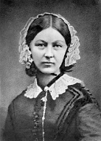  Lives of significant people:  Famous people from the UK |  |  | 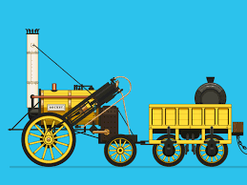  Local history: Did anything important ever happen in our town? (George Stephenson?)
Y2 | s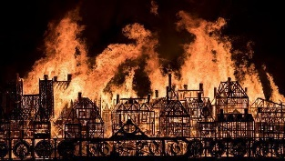  Events beyond living memory:  What do we know about the Great Fire of London? |  | 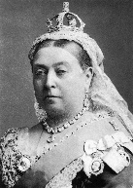  Events beyond living memory: Who were the Victorians? |  |  | 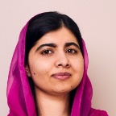  Lives of significant people:  Who are the famous people that have made an impact on the world? |  | 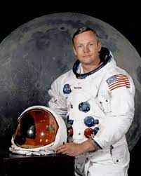  Lives of significant people:  How did the desire to conquer space create many heroes and heroines?

Y3 | 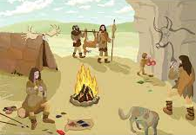  Chronology:  Who first lived in Britain? (the Stone Age to the Iron Age) | Ancient Greeks:  What did the Ancient Greeks give the world? | 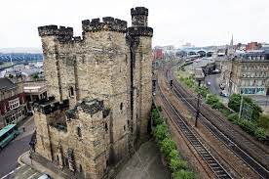  Local history:  Why does Newcastle exist in the first place?
Y4 | 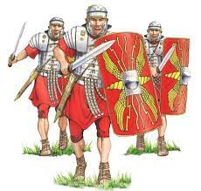  The Roman Empire and its impact on Britain: Who were the Romans and why were they so powerful? | 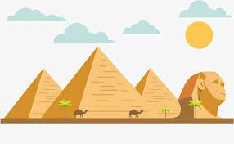  Ancient Civilizations:  How advanced were civilizations around 3000 years ago? (Ancient Egypt) | 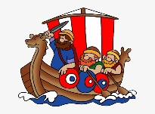  Chronology:  What was the battle like between the Anglo-Saxons and the Vikings for the Kingdom of England?

National Curriculum by Focus Education’s units
EYFS is not included in the Focus Education units and therefore this is not included in this list.

KS1 National Curriculum History content  Pupils should be taught about: | Havannah First School’s theme, running throughout the History curriculum. | Unit of Learning | Year Group it is taught in
Changes within living memory. Where appropriate, these should reveal aspects of change in national life. | Changes within living memory. | How were our grandparents’ toys different to ours? | 1
Events beyond living memory that are significant nationally or globally. | Events beyond living memory. | What do we know about the Great Fire of London?  Who were the Victorians? | 2
The lives of significant individuals in the past who have contributed to national and international achievements. Some should be used to compare aspects of life in different periods. | Lives of significant people or significant events. | Who were these famous people and why do we talk about them today?  Who are the famous people that have made an important impact on the world?  What do we know about the history of space travel? | 1  2  2
Significant historical events, people and places in their own locality. | Local history | Did anything important ever happen in our town? | 1

KS2 National Curriculum History content  Pupils should be taught about: | Havannah First School’s theme, running throughout the History curriculum. | Unit of Learning | Year Group it is taught in
changes in Britain from the Stone Age to the Iron Age | Chronology from the Stone Age to the 1066 | Who first lived in Britain? (the Stone Age to the Iron Age) | Y3
the Roman Empire and its impact on Britain |  | Who were the Romans and why were they so powerful? | Y4
Britain’s settlement by Anglo-Saxons and Scots |  | Taught in Y5 and 6 in Middle School
the Viking and Anglo-Saxon’s struggle for the Kingdom of England to the time of Edward the Confessor |  | What was the battle like between the Anglo-Saxons and the Vikings for the Kingdom of England? | Y4
a local history study | Local history | Why does Newcastle exist in the first place? | Y3
a study of an aspect or theme in British history that extends pupils’ chronological knowledge beyond 1066 | A study of an aspect or theme in British history that extends pupils’ chronological knowledge beyond 1066. | taught to Year 5 and 6 in Middle School
the achievements of the earliest civilizations – an overview of where and when the first civilizations appeared and a depth study of one of the following: Ancient Sumer; The Indus Valley; Ancient Egypt; The Shang Dynasty of Ancient China | Ancient civilizations | How advanced were the civilizations around 3000 years ago? (Ancient Egypt) | Y3
Ancient Greece - a study of Greek life and achievements and their influence on the western world | Ancient civilizations | How did the Ancient Greeks influence the world? | Y4

POTENTIAL EDUCATIONAL VISITS TO LINK WITH LEARNING IN HISTORY
It is suggested that an educational visit to enhance learning in History should take place at least once per year group. Below are suggestions, with the final decision being taken by teachers in each year group with the support of the History Subject Lead. In addition, loan boxes can be borrowed from Tyne and Wear Museums to give children a hands-on experience of artefacts related to the aspect of history that they are learning about. More information and lists of the boxes can be found here - https://twamschools.org.uk/boxes-of-delight. Suggested loan boxes are detailed below, but availability may be an issue to bookings need to be made well in advance of teaching.
R
Visit
Loan boxes | There are no loan boxes that are appropriate for children of this age range.
Y1 | Changes within living memory:  How were our grandparent’s toys different to ours? |  | 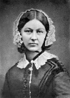  Lives of significant people:  Famous people from the UK |  | Local history: Did anything important ever happen in our town? (George Stephenson?)
Visit | ‘Lost in the Toy Museum’ Workshop from The Discovery Museum  https://discoverymuseum.org.uk/whats-on/lost-in-the-toy-museum-discover-a-story |  |  |  | Stephenson Steam Railway – possibility to visit with support from museum staff  https://stephensonsteamrailway.org.uk/
Loan boxes | 20th Century Toys |  | Victorians – Florence Nightingale |  | George and Robert Stephenson

Y2 | s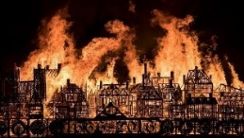  Events beyond living memory:  What do we know about the Great Fire of London? |  | 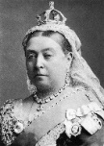  Events beyond living memory:  Who were the Victorians? |  | 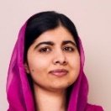  Lives of significant people:  Who are the famous people that have made an impact on the world? | Lives of significant people:  How did the desire to conquer space create many heroes and heroines?
Visit |  |  | Beamish with a focus on the school and life of children.  https://www.beamish.org.uk/learning/learning-activities/ |  | Space workshop at the Life Science Centre, Newcastle. https://www.life.org.uk/schools/workshops/key-stage-1
Loan boxes | Great Fire of Newcastle and Gateshead |  | Victorians – there are a range of boxes that can be selected from.
Y3 | Chronology:  Who lived in Britain first? (the Stone Age to the Iron Age) |  | Ancient Greeks:  What did the Ancient Greeks give the world? |  | Local history:  Why does Newcastle exist in the first place?
Visit | Investigating prehistory: the Stone Age and the Bronze Age - workshop at the Great North Museum: Hancock. https://greatnorthmuseum.org.uk/learning/history-workshops |  | Greek fighting forces / Ancient Greece hidden lives Women and Children – workshops at the Great North Museum: Hancock.  https://greatnorthmuseum.org.uk/learning/history-workshops |  | Newcastle Keep  https://www.newcastlecastle.co.uk/learning/primary
Loan boxes | Prehistoric Britain |  | Ancient Greece |  | North East History (possibiliity; but keep focus on development of the settlement)
Y4 | The Roman Empire and its impact on Britain: Who were the Romans and why were they so powerful? | Ancient Civilizations:  How advanced were civilizations around 3000 years ago? (Ancient Egypt) |  | Chronology:  What was the battle like between the Anglo-Saxons and the Vikings for the Kingdom of England?
Visit | Segedunum Roman Fort or Vinodolanda  https://segedunumromanfort.org.uk/  https://www.vindolanda.com/Pages/Category/schools | Who are the mummified people at the museum? – workshop at the Great North Museum: Hancock.  https://greatnorthmuseum.org.uk/learning/history-workshops |  | Possibility of Jarrow Hall, but need to ensure the correct focus of the unit is maintained.  https://jarrowhall.com/schools/
Loan boxes | Roman Britain: Hadrian’s Wall | Ancient Egypt |  | Anglo-Saxon Britain

