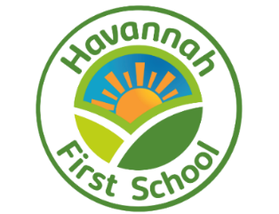

Long Term Plan for Art and Design
Havannah First School Art Units and Coverage

R
Y1 | Formal Elements  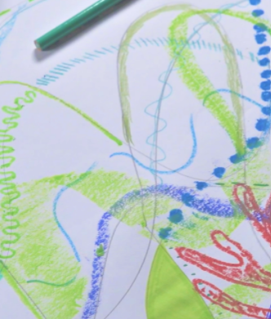  Exploring shape, line and colour: mixing and painting with secondary colours, using circles to create abstract compositions and working collaboratively to create a class piece of art inspired by water. | 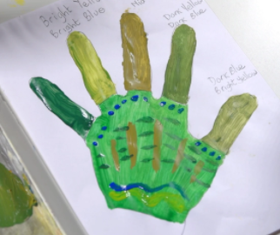  Skills  Developing design, drawing, craft, painting and art appreciation; undertaking two different printing techniques, using 2D shapes to explore a variety of media, mixing different shades of one colour and discussing the work of artist Louis Wain. | 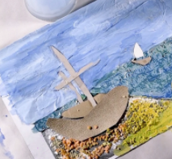  Landscapes  Using different media (Themes: The seaside, Castles) | 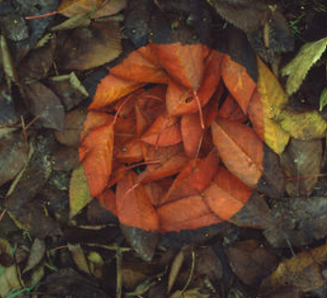  Sculptures and Collages  On the theme of the natural world, children create sculptures, collages, 3D models of creatures and a giant spider sculpture, inspired by Louise Bourgeois.
Y2 | 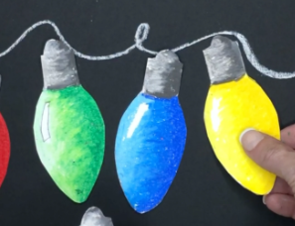  Formal Elements  Pattern, texture and tone: creating printed patterns using everyday objects, taking rubbings using different media and creating 3D drawings. | 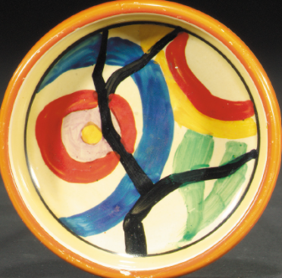  Skills  Design, drawing, craft, painting and art appreciation: replicating the recognisable crockery of Clarice Cliff, exploring tone through shading, developing weaving skills, working with clay and experimenting with brush strokes. | 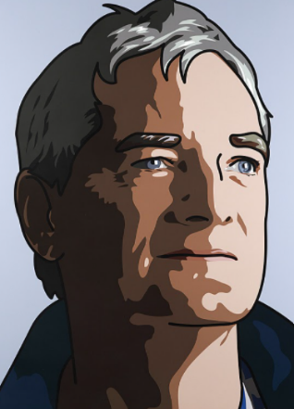  Human Form  Exploring how bodies and faces are portrayed in art: looking at works of art, creating collages, drawing portrait, creating a peg figure and collage. | 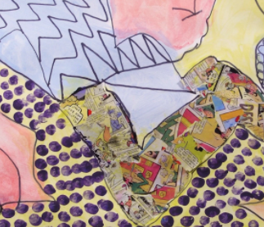  Sculpture and Mixed Media  Sculpture, pop art, drawing to portray emotions and taking inspiration from the works of Roy Lichtenstein.
Y3 | 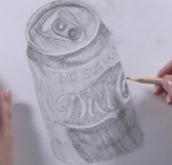  Formal Elements  Exploring shape and tone – identifying shapes in everyday objects, using shapes as guidelines to draw accurately from observation, creating form and shape using wire and shading from light to dark | 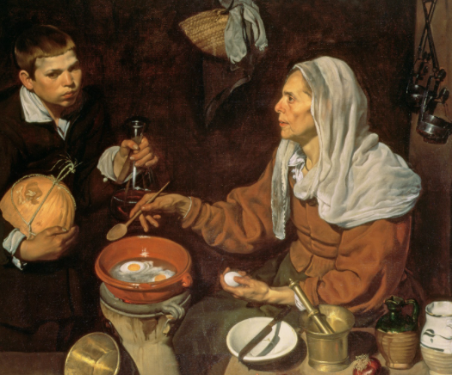  Skills  Design, drawing, craft, painting and art appreciation – creating puppets, drawing from observation, learning the difference between a tint and a shade and creating a version of a cartoon drawn by a famous illustrator | 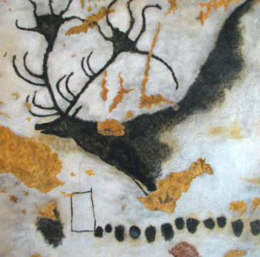  Prehistoric Art  Learning about how and why art was created thousands of years ago, making homemade paints from natural materials and replicating painting techniques from the past | 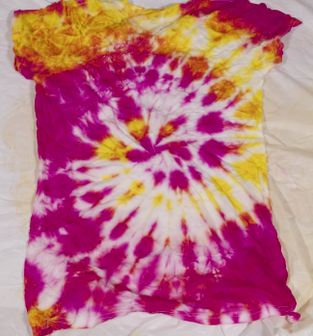  Craft  Creating mood boards as inspiration, learning to tie-dye, weaving and sewing to create a range of effects using fabric.
Y4 | 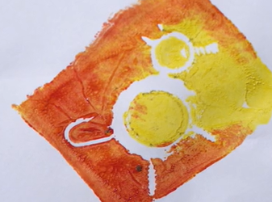  Formal Elements  Exploring texture and pattern – developing a range of mark-making techniques, making and printing with textured stamps for printing, drawing ‘flip’ patterns and recreating a famous geometric pattern. | 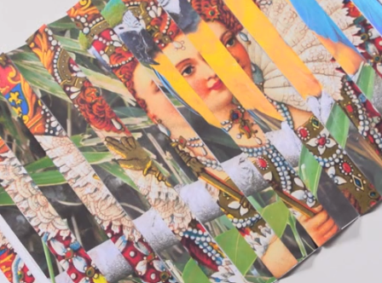  Skills  Developing: design, drawing, craft, painting skills – creating an optical illusion print, making a plate in the famous willow pattern, carving soap, still life drawing, painting and mixing colours in the style of Paul Cézanne and learning about the role of a ‘curator’ | 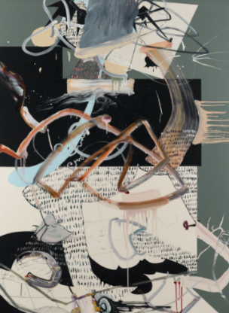  Every Picture Tells a Story  Analysing works of art, using inference and prediction to explore what might be depicted and intended by the artists. Creating photo collages and abstract art inspired by the work explored. | 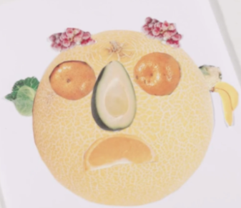  Sculpture  Learning about the works of inspirational sculptors, creating 3D works of art, working with recycled materials and making collages.

National Curriculum by Kapow Primary’s areas and units

KS1  National Curriculum Art & Design subject content  Pupils should be taught to: | Kapow Primary’s art & design areas | Kapow Primary’s units
To use a range of materials creatively to design and make products to use drawing, painting and sculpture to develop and share their ideas, experiences and imagination |  | Y1  Landscapes using different media  Formal elements,  Sculpture and collages  Art and design skills | Y2  Human form  Formal elements  Sculpture and mixed media  Art and design skills
To develop a wide range of art and design techniques in using colour, pattern, texture, line, shape, form and space |  | Y1  Landscapes using different media  Formal elements  Sculpture and collages  Art and design skills | Y2  Human form  Formal elements  Sculpture and mixed media  Art and design skills
About the work of a range of artists, craft makers and designers, describing the differences and similarities between different practices and disciplines, and making links to their own work. |  | Y1  Landscapes using different media  Formal elements  Sculpture and collages  Art and design skills | Y2  Human form  Formal elements  Sculpture and mixed media  Art and design skills
KS2
National Curriculum Art & Design subject content
Pupils should be taught to:
To create sketch books to record their observations and use them to review and revisit ideas |  | Y3  Prehistoric art  Formal elements  Craft  Art and design skills | Y4  Every picture tells a story  Formal elements  Sculpture  Art and design skills
To improve their mastery of art and design techniques, including drawing, painting and sculpture with a range of materials [for example, pencil, charcoal, paint, clay] |  | Y3  Prehistoric art  Formal elements  Craft  Art and design skills | Y4  Every picture tells a story  Formal elements  Sculpture  Art and design skills

