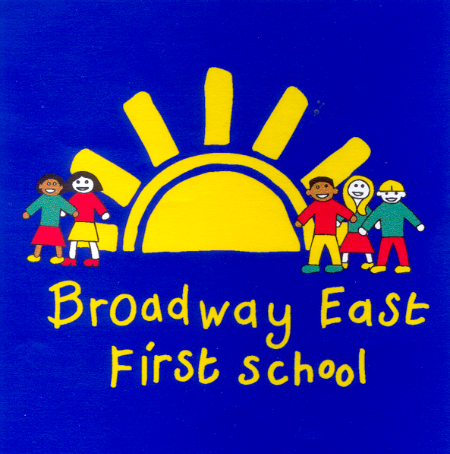

Safeguarding and Child Protection Policy
2020 - 21

Named personnel with designated responsibility for Safeguarding:

Designated Safeguarding Lead (DSL) | Deputy Safeguarding Lead | Deputy Safeguarding Lead | Nominated Safeguarding  Governor | Chair of Governors
Helen McKenna  (HT)  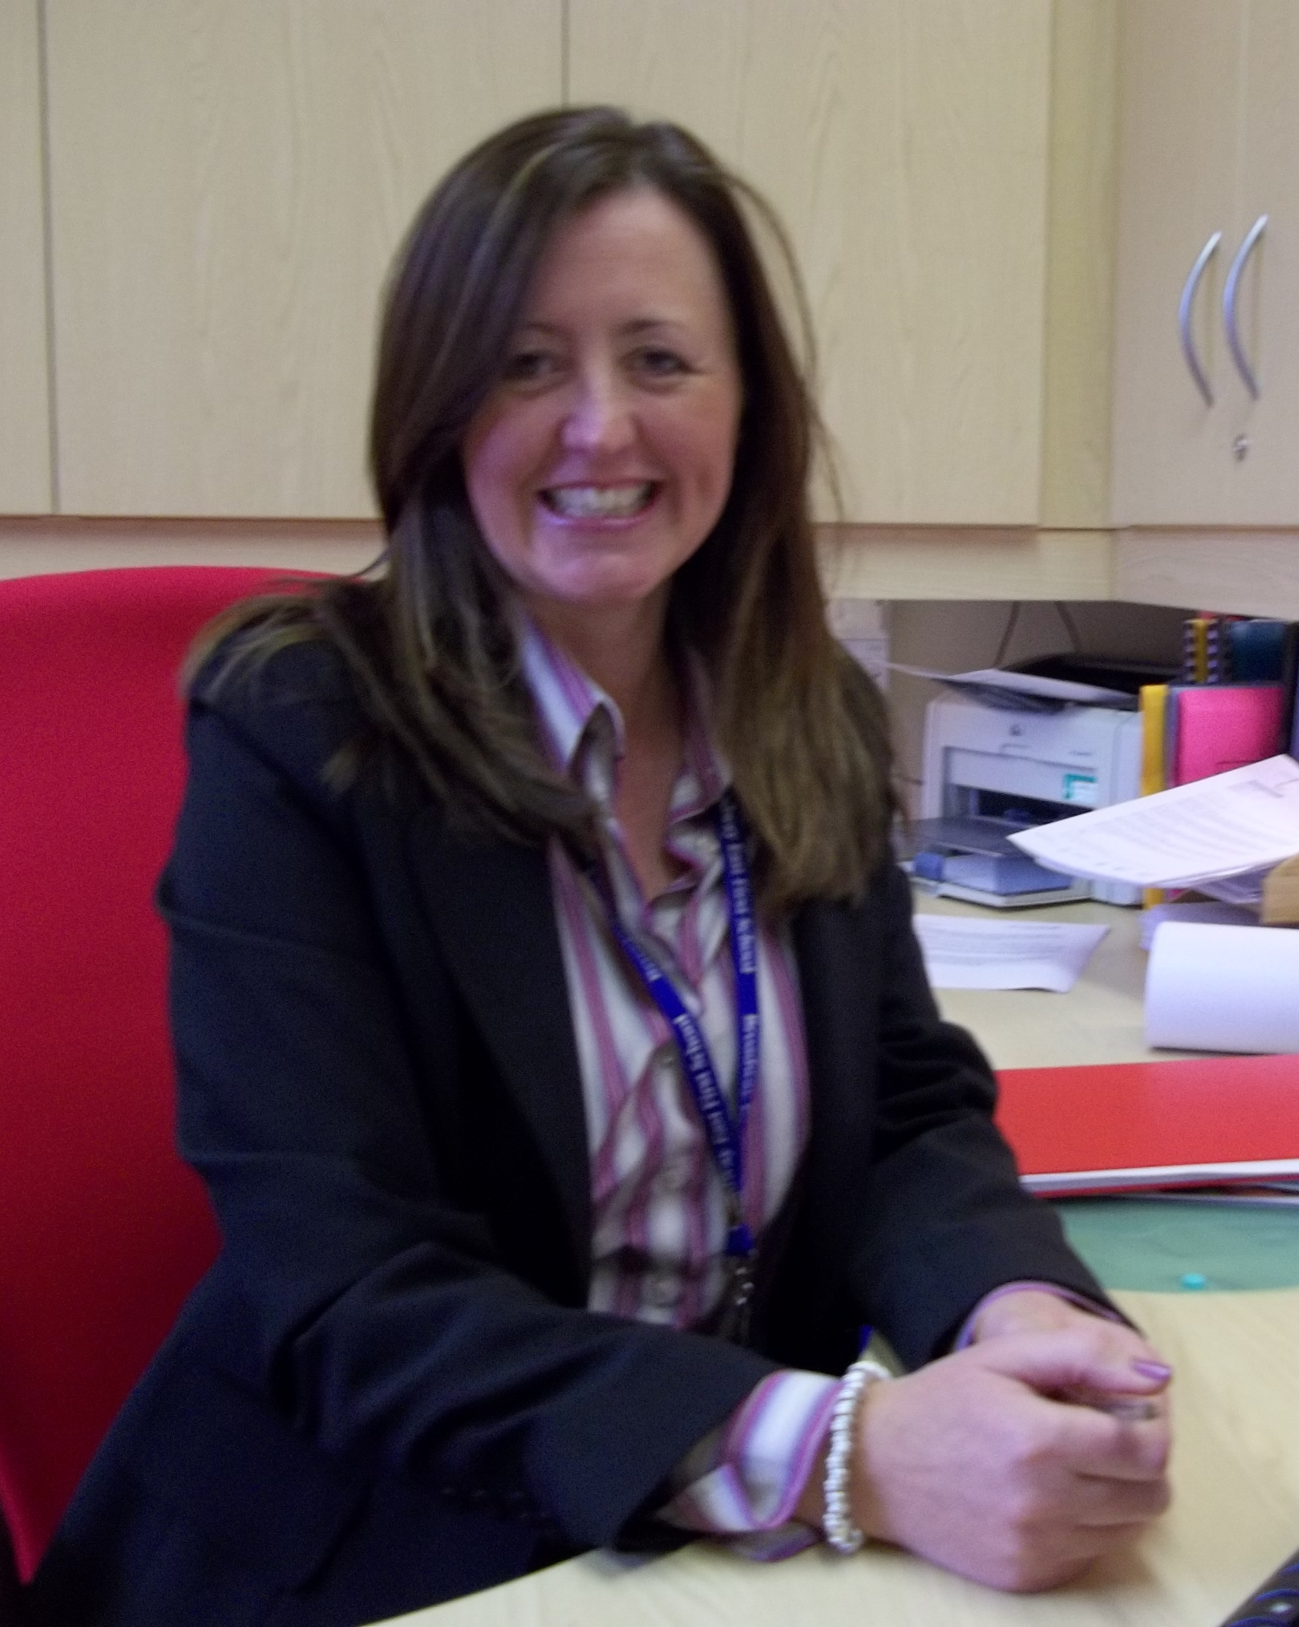 | Gary Burnett  (DHT)   |  | Rhonda Crosby | Tony Purdie

Agreed by GB: December 2016
Last Reviewed and agreed: Autumn 2017 Autumn 2018 Autumn 2019 Autumn 2020
Next review: Autumn 2021

Contents:
Section:

1 | Purpose & Aims | 4
2 | School Ethos | 4
3 | Roles & Responsibilities | 5
4 | Training & Induction | 7
5 | Procedures for Managing Concerns | 8
6  7 | Recording & Information Sharing  Working with Parents & Carers | 10  11
8 | Child Protection Conferences | 12
9 | Safer Recruitment | 12
10 | Safer Working Practice | 13
11 | Managing Allegations against Staff | 13
12 | Other relevant policies | 14
13 | Statutory Framework | 14
Appendices
A | Suspect child at risk action flow diagram | 15
B | Safeguarding induction sheet | 16
C | Abuse and Neglect | 17
D - L | Specific Safeguarding Issues: | 20
D1 | Child Criminal Exploitation (CCE) | 20  20  21
D2 | Child Sexual Exploitation (CSE) | 20  20  21
D3 | County Lines | 20  20  21
E | So-called “honour based” violence | 22
E1 | Female Genital Mutilation (FGM) | 22
E2 | Forced Marriage | 23
F | Preventing Radicalisation | 25
G | Private Fostering | 26
H | Children Missing Education (CME) | 27
I | Peer on Peer abuse | 28
J | Sexually Harmful Behaviour | 30
 | Sexual Violence and Harassment | 30
 | Upskirting | 31
 | Sexting | 31
K | Trafficking and Modern Slavery | 32
L | Domestic Abuse and Homelessness | 34
M | Key Safeguarding Contacts | 36
N | Example Cause for Concern form / body map | 38
O | DSL Action Checklist | 40

1. PURPOSE & AIMS

  - The purpose of Broadway East First School’s safeguarding policy is to ensure every child who is a registered pupil at our school is safe and protected from harm. This means we will always work to:

- Protect children and young people at our school from maltreatment;
- Prevent impairment of our children’s and young people’s mental and physical health or development;
- Ensure that children and young people at our school grow up in circumstances consistent with the provision of safe and effective care;
- Undertake that role so as to enable children and young people at our school to have the best outcomes.

1.2 This policy will give clear direction to staff, volunteers, visitors and parents about expected behaviour and our legal responsibility to safeguard and promote the welfare of all children at our school.

1.3 Our school fully recognises the contribution it can make to protect children from harm and supporting and promoting the welfare of all children who are registered pupils at our school. The elements of our policy are prevention, protection and support.

1.4 We recognise that our safeguarding responsibilities are clearly linked to our responsibilities for ensuring that appropriate safeguarding responses are in place for children who are absent from school or who go missing from education, particularly on repeat occasions. The Attendance Lead will regularly liaise with the Designated Safeguarding Lead (DSL) to discuss all persistently absent pupils and those who go missing to identify the risk of abuse and neglect including sexual abuse or exploitation and to ensure that appropriate safeguarding responses have been put in place to reduce the risk of future harm.

1.5 This policy applies to all pupils, staff, parents, governors, volunteers and visitors.

1.6 Prior to implementing this policy we have considered a range of factors to help us identify and focus on the key issues for our school and community. We have reviewed our referrals, reason and considered local context and local issues as well as discussed as a leadership team and with the Governing Body what our key priorities are.

2. OUR ETHOS

2.1 Every child’s welfare is of paramount importance. Our school will establish and maintain an ethos where pupils feel secure, are encouraged to talk, are listened to and are safe. Children at our school will be able to talk freely to any member of staff at our school if they are worried or concerned about something.

2.2 Everyone who comes into contact with children and their families has a role to play in safeguarding children. We recognise that staff at our school play a particularly important role as they are in a position to identify concerns early and provide help for children to prevent concerns from escalating. All staff are advised to maintain an attitude of ‘it could happen here’ where safeguarding is concerned. When concerned about the welfare of a child, staff members must always act in the best interests of the child.

  - All staff and regular visitors will, through training and induction, know how
to recognise indicators of concern, how to respond to a disclosure from a child and how to record and report this information. We will not make promises to any child and we will not keep secrets. Every child will know what the adult will have to do with any information they have chosen to disclose.

2.4 Throughout our curriculum we will provide activities and opportunities for children to develop the skills they need to identify risks and stay safe. This will also be extended to include material that will encourage our children to develop essential life skills. For example, circle time, listening systems, the PSHE curriculum, assemblies, visits and visitors and many other opportunities which arise in the curriculum. We work with a range of providers and partners including Safety Works, School Health, GEMS counsellor, CES, GEM etc, to ensure that children hear the same messages from a variety of adults and develop a broad and secure understanding of how they can stay safe, assess risk, and seek support.

  - At all times we will work in partnership and endeavour to establish effective working relationships with parents, carers and colleagues from other agencies in line with Working Together to Safeguard Children (2018) and Local Safeguarding Partners’ Procedures.

3. ROLES AND RESPONSIBILITIES

Role | Name | Contact Details
Designated Safeguarding Lead (DSL) | Helen McKenna | helen.mckenna@broadway.newcastle.sch.uk  0191 2855141
Deputy DSL | Gary Burnett | gary.burnett@broadway.newcastle.sch.uk  01912855141
Headteacher | Helen McKenna | helen.mckenna@broadway.newcastle.sch.uk  0191 2855141
Named Safeguarding Governor | Rhonda Crosby | Via the school office 01912855141
Chair of Governors | Tony Purdie | Via the school office 01912855141

3.1 It is the responsibility of every member of staff, volunteer and regular visitor to our school to ensure that they carry out the requirements of this policy and, at all times, work in a way that will safeguard and promote the welfare of all of the pupils at this school. This includes the responsibility to provide a safe environment in which children can learn.

The Governing Body

3.2 The Governing Body of Broadway East First School is accountable for ensuring the effectiveness of this policy and our compliance with it. Although our Governing Body takes collective responsibility to safeguard and promote the welfare of our pupils, we also have a named governor who champions safeguarding within the school.

3.3 The Governing Body will ensure that:

- The safeguarding policy is in place and is reviewed annually, is available publicly via our school website and has been written in line with Local Authority guidance and the requirements of the Local Safeguarding Partners’ policies and procedures;
- The school contributes to inter-agency working in line with Working Together to Safeguard Children (2018);
- A senior member of staff from the leadership team is designated to take the lead responsibility for safeguarding and child protection and that there is a deputy DSL(s) who is appropriately trained to deal with any issues in the absence of the DSL. There will always be cover for this role;
- All staff receive a safeguarding induction and are provided with a copy of this policy and the staff code of conduct;
- All staff undertake appropriate child protection training that is updated regularly, at least annually.
- Procedures are in place for dealing with allegations against members of staff and volunteers in line with statutory guidance;
- Safer recruitment practices are followed in accordance with the requirements of ’Keeping Children Safe in Education’ DfE (2020);
- They remedy without delay any weakness in regard to our safeguarding arrangements that are brought to their attention.

3.4 The governing body will receive an annual safeguarding report that will record the training that has taken place, the number of staff attending and any outstanding training requirements for the school. It will also record all safeguarding activity and will inform the governing body how the school meets its statutory requirements.

The governing body will also undertake a range of ‘safeguarding visits’ over the year to monitor compliance within the safeguarding agenda.

The Head Teacher

3.5 At Broadway East First School the Headteacher is responsible for:
- Identifying a senior member of staff from the leadership team to be the DSL;
- Identifying alternate members of staff to act as the DSL in her absence to ensure there is always cover for the role;
- Ensuring that the policies and procedures adopted by the governing body, particularly concerning referrals of cases of suspected abuse and neglect, are followed by all staff;
- Ensuring that all staff and volunteers feel able to raise concerns about poor or unsafe practice and such concerns are addressed sensitively in accordance with agreed whistle-blowing procedures;
- Liaise with the Local Authority Designated Officer (LADO) in the event of an allegation of abuse being made against a member of staff.

The Designated Safeguarding Lead (DSL)

  - The DSL is a senior member of staff, from the leadership team who takes lead responsibility for safeguarding and child protection within our school. The DSL will carry out her role in accordance with the responsibilities outlined in Annex B of ‘Keeping Children Safe in Education’ DfE (2020);

  - The DSL will provide advice and support to other staff on child welfare and child protection matters. Any concern for a child’s safety or welfare will be recorded in writing (or on CPOMS) and given to the DSL.

  - During term time the DSL and or a deputy will always be available (during school or college hours) for staff in the school to discuss any safeguarding concerns. If in exceptional circumstances, a DSL is not available on the school site in person, we will ensure that they are available via telephone and any other relevant media.

  - The DSL will manage referrals and will: refer cases of suspected abuse to children’s social care, refer cases to the Channel Programme if there is a radicalization concern, refer cases to the Disclosure and Barring service, and to the Police where a crime has been committed. The School will attend child protection conferences and core group meetings.

  - The DSL will liaise with the three safeguarding partners and other agencies where necessaty. Through regular training, knowledge and experience, the DSL will be equipped to attend and contribute to child protection case conferences, strategy discussions and other interagency meetings.

  - The DSL will maintain written records and child protection files ensuring that they are kept confidential and stored securely.

  - The DSL is responsible for ensuring that all staff members and volunteers are aware of our policy and the procedure they need to follow. They will ensure that all staff, volunteers and regular visitors have received appropriate child protection information during induction.

  - The DSL will help to promote educational outcomes by sharing information about the issues that children, including children with a social worker, are experiencing or have experienced, with teachers and leadership staff.

4. TRAINING & INDUCTION

4.1 When new staff join our school they will be informed within the first half term of the safeguarding arrangements in place, including the reporting and recording procedures. This programme will include information relating to signs and symptoms of abuse, how to manage a disclosure from a child, how to record and the remit of the role of the DSL. The training will also include information about whistle-blowing in respect of concerns about another adult’s behaviour and suitability to work with children.
They will be given:
- This policy
- Behaviour Policy
- Staff Code of Conduct
- Whistleblowing policy
- Part one and Annex of Keeping Children Safe in Education DfE (2019)
- Safeguarding Responses for Children who go Missing in Education
- Role and Identity of designated Safeguarding Lead and DSL deputies

Staff are expected to understand their own responsibilities. They will also be provided with info about CPOMs. Supply and short term staff will not have access to CPOMs and therefore will be informed to share concerns in writing with the DSL.

4.2 In addition to the safeguarding induction, we will ensure that mechanisms are in place to assist staff to understand and discharge their role and responsibilities as set out in Part one of ‘Keeping Children Safe in Education’ DfE (2020); In order to achieve this, we will ensure that:
- all members of staff will undertake appropriate safeguarding training on an annual basis.
- we will evaluate the impact of this training;
- all staff members receive regular safeguarding and child protection updates (for example, via email, e-bulletins, staff meetings), as required, but at least annually, to provide them with the relevant skills and knowledge to safeguard children effectively;
- we have written induction materials and regularly review these
- we hold weekly briefings where Teachers and TA staff raise concerns about vulnerable children and share relevant and appropriate/permissible information

4.3 All regular visitors, temporary staff and volunteers to our school will be given a set of our safeguarding procedures; they will be informed of whom our DSL and alternate staff members are and what the recording and reporting system is. (See Appendix B). we supply visitors and supply staff with an easy to read leaflet so that they are aware of their duties and what to do if they have concerns.

4.4 The DSL, the alternate designated members of staff and any other senior member of staff who may be in a position of making referrals or attending child protection conferences or core groups will attend appropriate training. In addition to formal training, DSL will ensure that they update their knowledge and skills at regular intervals, but at least annually, to keep up with any developments relevant to their role.

4.5 Our governing body will also undertake appropriate training to ensure they are able to carry out their duty to safeguard all of the children at our school.

4.6 We actively encourage all of our staff to keep up to date with the most recent local and national safeguarding advice and guidance, Annex A of ‘Keeping Children Safe in Education’ (2020) provides links to guidance on specific safeguarding issues. In addition, throughout the school year we will brief staff on key issues identified by the school.

4.7 All staff are expected to read these key documents and fully understand their responsibility.
1. Part One and Annex A of Keeping Children Safe in Education DfE (2020)
2. This Policy
3. Behaviour Policy
4. Staff Code of Conduct
5. Whistleblowing Policy
6. Safeguarding responses to children who go missing from education
7. Role and identity of the DSL and deputy DSL.

5. PROCEDURES FOR MANAGING CONCERNS

Staff must report any concerns that they have and not see these as insignificant. Staff should not assume that a colleague or another professional will take action and report or share the concern.
On occasion, a referral is justified by a single incident such as an injury or a disclosure of abuse. More often however, concerns accumulate over a period of time and are evidenced by building up a picture of harm over time. This is particularly true in cases of emotional abuse and neglect. In these circumstances, it is crucial that staff record and pass on concerns in accordance with this policy to allow the DSL to build up a picture and access support for the child at the earliest opportunity. A reliance on memory without accurate and contemporaneous records of concern could led to a failure to protect.

Staff must immediately report:

- any suspicion that a child is injured, marked, or bruised in a way which is not readily attributable to the normal knocks or scrapes received in play
- any explanation given which appears inconsistent or suspicious
- any behaviours which give rise to suspicions that a child may have suffered harm (e.g. worrying drawings or play)
- any concerns that a child may be suffering from inadequate care, ill treatment, or emotional maltreatment
- any concerns that a child is presenting signs or symptoms of abuse or neglect
- any significant changes in a child’s presentation, including non-attendance
- any hint or disclosure of abuse from any person
- any concerns regarding person(s) who may pose a risk to children (e.g. living in a household with children present)
Staff must also consider children who might present as vulnerable. (see appendix C)

5.2 Responding to Disclosure

Disclosures or information may be received from pupils, parents or other members of the public. School recognises that those who disclose such information may do so with difficulty, having chosen carefully to whom they will speak. Accordingly all staff will handle disclosures with sensitivity.

Such information cannot remain confidential and staff will immediately communicate what they have been told to the DSL. Staff will do this in person and via CPOMS.

Staff will not investigate but will, wherever possible, elicit enough information to pass on to the DSL in order that s/he can make an informed decision of what to do next.

Staff will:

- listen to and take seriously any disclosure or information that a child may be at risk of harm
- try to ensure that the person disclosing does not have to speak to another member of school staff
- clarify the information
- try to keep questions to a minimum and of an ‘open’ nature e.g. ‘Can you tell me what happened?’ rather than ‘Did x hit you?’
- try not to show signs of shock, horror or surprise
- not express feelings or judgments regarding any person alleged to have harmed the child
- explain sensitively to the person that they have a responsibility to refer the information to the senior designated person
- reassure and support the person as far as possible
- explain that only those who ‘need to know’ will be told
- explain what will happen next and that the person will be involved as appropriate
- complete a cause for concern form either individually or with the DSL (Appendix M)
- make a record on CPOMS

5.3 The DSL should be used as a first point of contact for concerns and queries regarding any safeguarding concern in our school. Any member of staff or visitor to the school who receives a disclosure of abuse or suspects that a child is at risk of harm must report it immediately to the DSL or, if unavailable, to the alternate designated person. In the absence of either of the above, the matter should be brought to the attention of the most senior member of staff.

5.4 All concerns about a child or young person should be reported without delay and recorded in writing on CPOMS and if necessary a Cause for Concern form which should then be added as a file to CPOMS.

5.5 Following receipt of any information raising concern, the DSL will consider what action to take and seek advice from Children’s Services as required. All concerns, discussions and decisions made, and the reasons for those decisions should be recorded in writing. If in doubt about recording requirements, staff should discuss this with the DSL.

5.6 It is not the responsibility of school staff to investigate welfare concerns or determine the truth of any disclosure or allegation. All staff, however, have a duty to recognise concerns and pass the information on in accordance with the procedures outlined in this policy.

5.7 All referrals will be made in line with Local Children’s Services procedures.

5.8 Broadway East First School adheres to child protection procedures that have been agreed locally through the Local Children’s Safeguarding Board. Where we identify children and families in need of support, we will carry out our responsibilities in accordance with local threshold guidance.

5.9 If, at any point, there is a risk of immediate serious harm to a child a referral should be made to Children’s Services immediately. Anybody can make a referral. If the child’s situation does not appear to be improving the staff member with concerns should press for re-consideration by raising concerns again with the DSL and/or the Headteacher. Concerns should always lead to help for the child at some point.

5.10 Staff should always follow the reporting procedures outlined in this policy in the first instance. However, they may also share information directly with Children’s Services, or the police if:
- the situation is an emergency and the DSL, their alternate and the Headteacher are all unavailable;
- they are convinced that a direct report is the only way to ensure the pupil’s safety.

5.11 Any member of staff who does not feel that concerns about a child have been responded to appropriately and in accordance with the procedures outlined in this policy should raise their concerns with the Headteacher or the Chair of Governors. If any member of staff does not feel the situation has been addressed appropriately at this point should contact Children’s Services directly with their concerns.

Early Help

5.12 If early help is appropriate, the Designated Safeguarding Lead (or deputy) will generally lead on liaising with other agencies and setting up an inter-agency assessment, as appropriate.
Staff may be required to support other agencies and professionals in an early help assessment and, in some cases, where education is the fundamental factor, acting as the lead practitioner.
Early help assessments should be kept under review and referred to social care for assessment if the child’s situation does not appear to be improving or is getting worse.
Vulnerability
Alongside the specific safeguarding issues listed below staff should consider children who may be particularly vulnerable to abuse and may require early help:
Factors that can increase vulnerabilities can include:
- any children with additional needs including;
- children with Special Educational Needs / Disabled children (SEND)
- children facing housing issues such as frequent moves and homelessness
- those living in families with chaotic lifestyles
- families with increased stress, parental mental health and/or drug and alcohol dependency
- those children living elsewhere, with friends, relatives, are in care or are leaving care
- Asylum Seekers / Refugees
- Those vulnerable to discrimination on the basis of their sexuality, race, religion, ethnicity or disability
- Children at risk from neglect or abuse including specific issues such as FGM, CSE, forced marriage, radicalisation and living in households with domestic abuse
- Children with communication difficulties
- Children without adequate parenting / supervision which could lead to abuse, risk-related behaviour and sexual exploitation.
This this not an exhaustive list but merely an example of vulnerabilities that staff must consider when identifying safeguarding concerns.

6. RECORDING AND INFORMATION SHARING

6.1 If staff are concerned about the welfare or safety of any child at our school they will record their concern on the school’s CPOMS system. If they are not able to access CPOMS they will make a written record and in both cases concerns should be passed to the DSL without delay.

6.2 Any information recorded will be kept in a separate named file, in a secure cabinet (or CPOMS) and not with the child’s academic file. These files will be the responsibility of the DSL. Child protection information will only be shared within school on the basis of ‘need to know in the child’s interests’ and on the understanding that it remains strictly confidential.

6.3 Child protection information will be kept in the child’s individual file CP file for each child. Child protection information will only be kept in the file and this file will be kept up to date. Records of concern, copies of referrals, invitations to child protection conferences, core groups and reports will be stored here. All our safeguarding files will include; a chronology, contents front cover and will record significant events in the child’s life.

6.4 CP files will be the responsibility of the DSL. CP information will only be shared with relevant staff/agencies on a need to know basis in the child’s interests and on the understanding that it remains strictly confidential.

6.5 When a child leaves our school, the DSL will make contact with the DSL at the new school and will ensure that the child protection file is forwarded to the receiving school in an appropriately agreed manner. We will retain evidence to demonstrate we have acted accordingly when dealing with safeguarding matters and how the file has been transferred; this may be in the form of a written confirmation of receipt from the receiving school and/or evidence of recorded delivery and/or in the form of electronic recording on CPOMS. Where a parent elects to remove their child from the school roll to home educate, the school will make arrangements to pass any safeguarding concerns to the Local Authority.

Please see our information policy for further information about how we store and used data.

7. WORKING WITH PARENTS & CARERS

7.1 Broadway East First School is committed to working in partnership with parents/carers to safeguard and promote the welfare of children and to support them to understand our statutory responsibilities in this area.

7.2 When new pupils join our school, parents and carers will be informed that we have a safeguarding policy. A copy will be provided to parents on request and is available on the school website. Parents and carers will be informed of our legal duty to assist our colleagues in other agencies with child protection enquiries and what happens should we have cause to make a referral to Children’s Services.

7.3 We are committed to working with parents positively, openly and honestly. We ensure that all parents are treated with respect, dignity and courtesy. We respect parents’ rights to privacy and confidentiality and will not share sensitive information unless we have permission or it is necessary to do so in order to safeguard a child from harm.

  - We will seek to share with parents any concerns we may have about their
child unless to do so may place a child at increased risk of harm. A lack of parental engagement or agreement regarding the concerns the school has about a child will not prevent the DSL making a referral to Children’s Services in those circumstances where it is appropriate to do so.

  - In order to keep children safe and provide appropriate care for them, the school requires parents to provide accurate and up to date information regarding:

- Full names and contact details of all adults with whom the child normally lives;
- Full names and contact details of all persons with parental responsibility (if different from above);
- Emergency contact details (if different from above);
- Full details of any other adult authorised by the parent to collect the child from school (if different from the above).

The School will retain this information on the pupil file and wherever possible will hold more than one emergency contact for each child. The school will only share information about pupils with adults who have parental responsibility for a pupil or where a parent has given permission and the school has been supplied with the adult’s full details in writing. If in any doubt about information sharing, staff should speak to the DSL or deputy DSL. Fears about sharing information must not be allowed to stand in the way of the need to promote the welfare and protect the safety of children.

8. CHILD PROTECTION CONFERENCES

8.1 Children’s Services will convene a Child Protection conference once a child protection enquiry under Section 47 of the Children Act 1989 has been undertaken and the child is judged to be at continuing risk of significant harm. A review conference will take place once a child has been made the subject of a Child Protection Plan in order to monitor the safety of the child and the required reduction in risk.

8.2 Staff members may be asked to attend a child protection conference or core group meetings on behalf of the school in respect of individual children. Usually the person representing the school at these meetings will be the Headteacher or DSL. In any event, the person attending will need to have as much relevant up to date information about the child as possible; any member of staff may be required to contribute to this process.

8.3 All reports for child protection conferences will be prepared in advance using the guidance and template report. The information contained in the report will be shared with parents before the conference as appropriate and will include information relating to the child’s physical, emotional and intellectual development and the child’s presentation at school. In order to complete such reports, all relevant information will be sought from staff working with the child in school.

8.4 Clearly child protection conferences can be upsetting for parents. We recognise that we are likely to have more contact with parents than other professionals involved. We will work in an open and honest way with any parent whose child has been referred to Children’s Services or whose child is subject to a child protection plan. Our responsibility is to promote the protection and welfare of all children and our aim is to achieve this in partnership with our parents.

9. SAFER RECRUITMENT

9.1 We will ensure that the Headteacher and at least one member of the Governing Body have completed appropriate safer recruitment training. At all times the Headteacher and Governing Body will ensure that safer recruitment practices are followed in accordance with the requirements of ‘Keeping Children Safe in Education’, DfE (2020).

9.2 we will follow the recruitment and selection procdures when making decisions about the suitability of prospective employees. This will include: conduction the relelvant checks, obtaining appropriate references and information from interviews.

9.3 We will maintain a Single Central Register of all safer recruitment checks carried out in line with statutory requirements.

10. SAFER WORKING PRACTICE

10.1 All staff have a responsibility to maintain public confidence in their ability to safeguard the welfare and best interests of children. They should adopt high standards of personal conduct in order to maintain confidence and respect of the general public and those with whom they work.

10.2 All staff will be provided with a copy of our school’s code of conduct at induction. This sets out the school’s expectations of staff behaviour. We review this annually and aske staff annually to ensure that they are familiar with the updated version. Staff are expected to carry out their duties in accordance with the Code of Conduct.

10.3 There will be occasions when some form of physical contact is inevitable, for example if a child has an accident or is hurt or is in a situation of danger to themselves or others around them. However, at all times the agreed policy for positive handling must be adhered to.

10.3 If staff, visitors, volunteers or parent helpers are working with children alone they must ensure that they are visible to other members of staff. They will be expected to inform another member of staff of their whereabouts in school, who they are with and for how long. Doors, ideally, should have a clear glass panel in them and be left open.

10.4 Staff are responsible for their own actions and behaviour and should avoid any conduct which would lead any reasonable person to question their motivation and intentions.

10.4 Further advice and guidance can be found in ‘Guidance for Safer Working Practices for Adults who work with Children and Young People in Education Settings’ (2019). All staff and volunteers are expected to carry out their work in accordance with this guidance and will be made aware that failure to do so could lead to disciplinary action.

11. MANAGING ALLEGATIONS AGAINST STAFF & VOLUNTEERS

11.1 We will take all possible steps to safeguard our children and to ensure that the adults in our school are safe to work with children. We will always ensure that the procedures outlined in the local procedures and Part 4 of ‘Keeping Children Safe in Education’, DfE (2020) are adhered to and will seek appropriate advice from the Local Authority Designated Officer (LADO). The LADO can be contacted to request a consultation or to make a referral.

11.2 If an allegation is made or information is received about any adult who works in our setting which indicates that they may be unsuitable to work with children, the member of staff receiving the information should inform the Headteacher immediately. This includes concerns relating to agency and supply staff and volunteers. Should an allegation be made against the Headteacher, this will be reported to the Chair of Governors. In the event that neither the Headteacher nor Chair of Governors is contactable on that day, the information must be passed to and dealt with by either the member of staff acting as Headteacher or the Vice Chair of Governors.

11.3 The Headteacher or Chair of Governors will seek advice from the LADO within one working day. No member of staff or the governing body will undertake further investigations before receiving advice from the LADO.

11.4 Any member of staff or volunteer who does not feel confident to raise their concerns with the Headteacher or Chair of Governors should contact the LADO directly. Further national guidance can be found at: Advice on whistleblowing. The NSPCC whistleblowing helpline is also available for staff who do not feel able to raise concerns regarding child protection failures internally. Staff can call: 0800 028 0285 – line is available from 8:00am to 8:00pm, Monday to Friday or via e-mail: help@nspcc.org.uk.

11.5 The School has a legal duty to refer to the Disclosure and Barring Service anyone who has harmed, or poses a risk of harm, to a child, or if there is reason to believe the member of staff has committed one of a number of listed offences, and who has been removed from working (paid or unpaid) in regulated activity, or would have been removed had they not left. The DBS will consider whether to bar the person. If these circumstances arise in relation to a member of staff at our school, a referral will be made as soon as possible after the resignation or removal of the individual in accordance with advice from the LADO and/or HR.

12. RELEVANT POLICIES

12.1 To underpin the values and ethos of our school and our intent to ensure that pupils at our school are appropriately safeguarded the following policies are also included under our safeguarding umbrella:

- Staff Code of Conduct
- Anti-Bullying
- Positive Handling
- Behaviour
- Recruitment & Selection
- Whistle-blowing
- Attendance
- On-line Safety
- Health and Safety including site security
- Harassment and discrimination including racial abuse
- Meeting the needs of pupils with medical conditions
- Intimate Care
- First aid
- Educational visits including residentials
- Information and Data Protection (GDPR related Policies)

13. STATUTORY FRAMEWORK

This policy has been devised in accordance with the following legislation and guidance:

- ‘Working Together to Safeguard Children: A guide to inter-agency working to safeguard and promote the welfare of children’, DfE (2018)
- ‘Keeping Children Safe in Education’, DfE (2020)
- Local Safeguarding procedures
- Guidance for Safer Working Practices for Adults who work with Children and Young People in Education Settings (May 2019).
- ‘What to do if you're worried a child is being abused’, DfE (March 2015)
- ‘Information Sharing: Advice for practitioners’, DfE (March 2015)
- ‘The Prevent duty: Departmental advice for schools and childcare providers’, DfE (2015)
- ‘Mandatory Reporting of Female Genital Mutilation – procedural information’ Home Office (October 2015)

- Appendix A – Suspect child at risk action to take

Broadway East First School
Channels of communication should be quick and clear:

Identified Concern
Consult with Designated Safeguarding Lead or Nominated Deputy
Together clarify concern**
Decision

Alternative Action
Suspicions are very strong and further action needed

Designated Safeguarding Lead (or deputy DSL) to make enquiry to
to Children’s Services Social Care Department, followed up in writing

**
Any member of staff who is unhappy with the joint decision made with the Designated Person can consult with the Head teacher/Chair of governors or seek advice from key staff within the Local Authority

Appendix B: Safeguarding Induction Sheet
(For new or supply staff and regular visitors or volunteers)

We all have a statutory duty to safeguard and promote the welfare of children, and at our school we take this responsibility seriously.

If you have any concerns about a child or young person in our school, you must share this information immediately with our DSL or one of the alternate post holders.

Do not think that your worry is insignificant if it is about hygiene, appearance or behaviour – we would rather you told us as we would rather know about something that appears small than miss a worrying situation.

If you think the matter is very serious and may be related to child protection, for example, physical, emotional, sexual abuse or neglect, you must find one of the designated professionals detailed below and provide them with a written record of your concern. A copy of the form to complete is attached to this and others can be obtained from the workroom (on the shelves above the colour printer) Please ensure you complete all sections as described.

If you are unable to locate them ask a member of the school office staff to find them and to ask them to speak with you immediately about a confidential and urgent matter. Mrs Lancaster or Mrs Whatnell in the office will always be aware of the Head’s (and DSL’s) location and will be able to contact her or the DSL or a senior member of staff quickly.

Any allegation concerning a member of staff, a child’s foster carer or a volunteer should be reported immediately to the Head teacher. If an allegation is made about the Head teacher you should pass this information to the Chair of the Governing Body. Alternatively, you can contact the Local Authority Designated Officer on 01603 223473. NSPCC whistleblowing helpline is also available for staff who do not feel able to raise concerns regarding child protection failures internally. Staff can call: 0800 028 0285 – line is available from 8:00am to 8:00pm, Monday to Friday or via e-mail: help@nspcc.org.uk.

The people you should talk to in school are:
Designated Safeguarding Lead (DSL): | Helen McKenna
Location of office: | Between the office and staffroom in main building
Contact Number: | 0191 2855141
Alternate Designated Lead: | Gary Burnett
Location of office: | Class 7 or the HT office as above
Contact Number: | 01912855141
Chair of Governing Body | Dr Purdie
Contact Number: | Via the school office 01912855141

At Broadway East First School we strive to safeguard and promote the welfare of all of our children.

Appendix C Abuse and Neglect
Abuse and Neglect
Knowing what to look for is vital to the early identification of abuse and neglect. All staff should be aware of the indicators of abuse and neglect so that they are able to identify cases of children who may be in need of help or protection. If staff are unsure they should always speak to the Designated Safeguarding Lead (or deputy)
Abuse, neglect and safeguarding issues are rarely stand-alone events that can be covered by one definition or label. In most cases, multiple issues will overlap with one another.
Indicators of abuse and neglect
Abuse: a form of maltreatment of a child. Somebody may abuse or neglect a child by inflicting harm or failing to act to prevent harm. Children may be abused in a family or in an institutional or community setting; by those known to them, or, more rarely, by others. Abuse can take place wholly online, or technology may be used to facilitate offline abuse. Children may be abused by an adult or adults or by another child or children.
We recognise that children are also vulnerable to physical, sexual and emotional abuse by their peers or siblings. This is most likely to include, but not limited to:

- bullying (including cyber bullying)
- physical abuse, hitting, kicking, shaking, biting, hair pulling or otherwise causing physical harm
- gender based violence/sexual assaults
- sexting (also known as youth produced sexual imagery)
- initiation / hazing type violence and ritual

Abuse perpetrated by children can be just as harmful as that perpetrated by an adult, so it is important to remember the impact on the victim of the abuse as well as to focus on the support for the child or young person exhibiting the harmful behaviour. Such abuse will always be taken as seriously as abuse perpetrated by an adult and the same safeguarding children procedures will apply in respect of any child who is suffering or likely to suffer significant harm; staff must never tolerate or dismiss concerns relating to peer on peer abuse.
Physical Abuse may involve hitting, shaking, throwing, poisoning, burning or scalding, drowning, suffocating or otherwise causing physical harm to a child. Physical harm may also be caused when a parent or carer fabricates the symptoms of or deliberately induces illness in a child.
Sexual Abuse involves forcing or enticing a child or young person to take part in sexual activities, not necessarily involving a high level of violence, whether or not the child is aware of what is happening. The activities may involve physical contact, including assault by penetration (for example, rape or oral sex) or non-penetrative acts such as masturbation, kissing, rubbing and touching outside of clothing. They may also include non-contact activities, such as involving children in looking at, or in the production of, sexual images, watching sexual activities, encouraging children to behave in sexually inappropriate ways, or grooming a child in preparation for abuse (including via the internet). Sexual abuse is not solely perpetrated by adult males. Women can also commit acts of sexual abuse, as can other children.
Emotional Abuse is the persistent emotional maltreatment of a child such as to cause severe and persistent adverse effects on the child’s emotional development.
It may involve conveying to children that they are worthless or unloved, inadequate, or valued only insofar as they meet the needs of another person. It may include not giving the child opportunities to express their views, deliberately silencing them or ‘making fun’ of what they say or how they communicate. It may feature age or developmentally inappropriate expectations being imposed on children. These may include interactions that are beyond the child’s developmental capability, as well as overprotection and limitation of exploration and learning, or preventing the child participating in normal social interaction. It may involve seeing or hearing the ill-treatment of another. It may involve serious bullying (including cyberbullying), causing children frequently to feel frightened or in danger, or the exploitation or corruption of children. Some level of emotional abuse is involved in all types of maltreatment of a child, though it may occur alone.
We recognise that children with special educational needs (SEN) and disabilities can face additional safeguarding challenges and these are discussed in staff training. These additional barriers can include:
- assumptions that indicators of possible abuse such as behaviour, mood and injury relate to the child’s disability without further exploration;
- children with SEN and disabilities can be disproportionally impacted by things like bullying - without outwardly showing any signs; and
- communication barriers and difficulties in overcoming these barriers.
Negl Neglect is the persistent failure to meet a child’s basic physical and/or psychological needs, likely to result in the serious impairment of the child’s health or development. Neglect may occur during pregnancy as a result of maternal substance abuse. Once a child is born, neglect may involve a parent or carer failing to:
- provide adequate food and clothing, shelter (including exclusion from home or abandonment)
- protect a child from physical and emotional harm or danger
- ensure adequate supervision (including the use of inadequate caretakers)
- ensure access to appropriate medical care or treatment.
It may also include neglect of, or unresponsiveness to, a child’s basic emotional needs.
Contextual Safeguarding
Safeguarding incidents and/or behaviours can be associated with factors outside school or college and/or can occur between children outside the school or college. All staff should be considering the context within such incidents and/or behaviours occur. This is known as contextual safeguarding, which simply means assessments of children should consider whether wider environmental factors are present in a child’s life that are a threat to their safety and/or welfare.

Geographical factors | School’s Response
- We have a close proximity to the Great North Road | - Full Road protection training for R and KS1.  - Paedestrian training for KS2.
Social and economic factors | Schools Response
- Very mixed cohorts in terms of Socio economic factors | - Staff have an awareness of the challenges for some children and well-being support is put in place  - No outsiders school
Peer Group factors | Schools Response
- Pupils have older siblings who may be influential to younger family members. | - Our curriculum teaches pupils about the issue of ‘peer pressure’. Pupils engage in different scenarios and are given choices to make through role play. Pupils are taught to be confident and assertive through our PSHCE curriculum.
Home factors | Schools Response
- Lots of our pupils are connected to the internet at home and regularly use gaming devices to engage in online games with their friends. | - Through our Computing Curriculum, pupils are taught about online safety. Every pupil has signed our ‘Acceptable Use’ contract. Our external computing advisor also delivers specific workshops in relation to any online or mobile phone incident. This proactive and responsive approach allows us to target certain groups of pupils or individuals and gives us the flexibility to respond to school incidents. Parents are also given the opportunity to meet our advisor and talk with him during our parental workshops.

Specific Safeguarding Issues
Appendix D: Child Exploitation
Appendix D1 - Child Criminal Exploitation
CCE is where an individual or group takes advantage of an imbalance of power to coerce, control, manipulate or deceive a child into any criminal activity (a) in exchange for something the victim needs or wants, and/or (b) for the financial or other advantage of the perpetrator or facilitator and/or (c) through violence or the threat of violence. The victim may have been criminally exploited even if the activity appears consensual. CCE does not always involve physical contact; it can also occur through the use of technology. CCE can include children being forced to work in cannabis factories, being coerced into moving drugs or money across the country (county lines, see D3), forced to shoplift or pickpocket, or to threaten other young people. Some of the following can be indicators of CCE:
- children who appear with unexplained gifts or new possessions
- children who associate with other young people involved in exploitation
- children who suffer from changes in emotional well-being
- children who misuse drugs and alcohol
- children who go missing for periods of time or regularly come home late
- children who regularly miss school or education or do not take part in education.

Appendix D2 - Child Sexual Exploitation
CSE occurs where an individual or group takes advantage of an imbalance of power to coerce, manipulate or deceive a child into sexual activity (a) in exchange for something the victim needs or wants, and/or (b) for the financial advantage or increased status of the perpetrator or facilitator. The victim may have been sexually exploited even if the sexual activity appears consensual. CSE does not always involve physical contact; it can also occur through the use of technology. CSE can affect any child or young person (male or female) under the age of 18 years, including 16 and 17 year olds who can legally consent to have sex. It can include both contact (penetrative and non-penetrative acts) and non-contact sexual activity and may occur without the child or young person’s immediate knowledge (e.g. through others copying videos or images they have created and posted on social media).

The following list of indicators is not exhaustive or definitive but it does highlight common signs which can assist professionals in identifying children or young people who may be victims of sexual exploitation.

Signs include:

- underage sexual activity
- inappropriate sexual or sexualised behaviour
- sexually risky behaviour, e.g. 'swapping' sex
- repeated sexually transmitted infections
- in girls, repeated pregnancy, abortions, miscarriage
- receiving unexplained gifts or gifts from unknown sources
- having multiple mobile phones and worrying about losing contact via mobile phone
- having unaffordable new things (clothes, mobile phone) or expensive habits (alcohol, drugs)
- changes in the way they dress
- going to hotels or other unusual locations to meet friends
- seen at known places of concern
- moving around the country, appearing in new towns or cities, not knowing where they are
- getting in/out of different cars driven by unknown adults
- having older boyfriends or girlfriends
- contact with known perpetrators
- involved in abusive relationships, intimidated and fearful of certain people or situations
- hanging out with groups of older people, or anti-social groups, or with other vulnerable peers
- associating with other young people involved in sexual exploitation
- recruiting other young people into exploitative situations
- truancy, exclusion, disengagement with school, opting out of education altogether
- unexplained changes in behaviour or personality (chaotic, aggressive, sexual, mood swings, volatile behaviour, emotional distress
- self-harming, suicidal thoughts, suicide attempts, overdosing, eating disorders
- drug or alcohol misuse
- getting involved in crime / police involvement, police records
- involved in gangs, gang fights, gang membership
- injuries from physical assault, physical restraint, sexual assault

Appendix D3 - County Lines
County lines is a term used to describe gangs and organised criminal networks involved in exporting illegal drugs (primarily crack cocaine and heroin) into one or more importing areas [within the UK], using dedicated mobile phone lines or other form of “deal line”.

Criminal exploitation of children is a geographically widespread form of harm that is a typical feature of county lines. Criminal networks or gangs groom and exploit children and young people to carry drugs and money from urban areas to suburban and rural areas, market and seaside towns. Offenders will often use coercion, intimidation, violence (including sexual violence) and weapons to ensure compliance of victims. Children can be targeted and recruited into county lines in a number of locations including schools, further and higher educational institutions, pupil referral units, special educational needs schools, children’s homes and care homes. Key to identifying potential involvement in county lines are missing episodes, when the victim may have been trafficked for purposes of transporting drugs. A referral to the National Referral Mechanism should be considered. Like other forms of abuse and exploitation, county line exploitation:

Signs and Symptoms may include:

- persistently going missing from home or school
- being found out of area
- unexplained acquisition of money, clothes or mobile phone
- excessive receipt of calls and text messages
- relationships with older, controlling individuals
- associated with gangs
- leaving home or care without explanation
- suspicion of self-harm, physical assault or unexplained injuries
- parental concerns
- significant decline in school performance
- significant changes in emotional wellbeing

Appendix E: So called ‘honour-based’ abuse

So-called ‘honour-based’ abuse (HBA) encompasses incidents or crimes which have been committed to protect or defend the honour of the family and/or the community, including:
- Female Genital Mutilation
- Forced Marriage
- Breast Ironing
Abuse committed in the context of preserving “honour” often involves a wider network of family or community pressure and can include multiple perpetrators. It is important to be aware of this dynamic and additional risk factors when deciding what form of safeguarding action to take. All forms of HBA are abuse (regardless of the motivation) and should be handled and escalated as such. If in any doubt, staff should speak to the Designated Safeguarding Lead (or deputy). Professionals in all agencies, and individuals and groups in relevant communities, need to be alert to the possibility of a child being at risk of HBA, or already having suffered HBA.

E1: Female Genital Mutilation (FGM)
It is essential that staff are aware of FGM practices and the need to look for signs, symptoms and other indicators of FGM.
What is FGM?
It involves procedures that intentionally alter/injure the female genital organs for non-medical reasons.
4 types of procedure:
Type 1 | Type 2 | Type 3 | Type 4
Clitoridectomy:  partial/total removal of clitoris | Excision:  partial/total removal of clitoris and labia minora | Infibulation entrance to vagina is narrowed by repositioning the inner/outer labia | All other procedures that may include: pricking, piercing, incising, cauterising and scraping the genital area.
Why is it carried out?
Belief that:
- FGM brings status/respect to the girl – social acceptance for marriage
- Preserves a girl’s virginity
- Part of being a woman / rite of passage
- Upholds family honour
- Cleanses and purifies the girl
- Gives a sense of belonging to the community
- Fulfils a religious requirement
- Perpetuates a custom/tradition
- Helps girls be clean / hygienic
- Is cosmetically desirable
- Mistakenly believed to make childbirth easier

Is FGM legal?
FGM is internationally recognised as a violation of human rights of girls and women. It is illegal in most countries, including the UK:
Circumstances and occurrences that may point to FGM happening
- Child talking about getting ready for a special ceremony
- Family taking a long trip abroad
- Child’s family being from one of the ‘at risk’ communities for FGM (Kenya, Somalia, Sudan, Sierra Leon, Egypt, Nigeria, Eritrea as well as non-African communities including Yemeni, Afghani, Kurdistan, Indonesia and Pakistan)
- Knowledge that the child’s sibling has undergone FGM
- Child talks about going abroad to be ‘cut’ or to prepare for marriage

Signs that may indicate a child has undergone FGM:
- Prolonged absence from school and other activities
- Behaviour change on return from a holiday abroad, such as being withdrawn and appearing subdued
- Bladder or menstrual problems
- Finding it difficult to sit still and looking uncomfortable
- Complaining about pain between the legs
- Mentioning something that somebody did to them that they are not allowed to talk about
- Secretive behaviour, including isolating themselves from the group
- Reluctance to take part in physical activity
- Repeated urinary tract infections
- Disclosure

The ‘One Chance’ rule:
As with Forced Marriage there is the ‘One Chance’ rule. It is essential that settings /schools/colleges take action without delay.
Where FGM has taken place, there has been a mandatory reporting duty placed on teachers since 31st October 2015. Section 5B of the Female Genital Mutilation Act 2003 (as inserted by section 74 of the Serious Crime Act 2015) places a statutory duty upon teachers in England and Wales, to report to the police where they discover (either through disclosure by the victim or visual evidence) that FGM appears to have been carried out on a girl under 18. Those failing to report such cases will face disciplinary sanctions. Further information on when and how to make a report can be found in the following Home Office guidance: 'Mandatory Reporting of Female Genital Mutilation - procedural information' (October 2015).

Appendix E2: Forced Marriage

Forcing a person into marriage is a crime in England and Wales. A forced marriage is one entered into without the full and free consent of one or both parties and where violence, threats or any other form of coercion is used to cause a person to enter into the marriage. Threats can be physical or emotional and psychological. A lack of full and free consent can be where a person does not consent or where they cannot consent (if they have learning disabilities, for example). Nevertheless, some communities use religion and culture as a way to coerce a person into marriage. Schools and colleges can play an important role in safeguarding children from forced marriage.
(KCSIE 2020)
Signs and symptoms may include:
- Students may appear anxious, depressed and emotionally withdrawn with low self-esteem.
- They may have mental health disorders and display behaviours such as self-harming, self-cutting or anorexia
- Sometimes they may come to the attention of the police having been discovered shoplifting or taking drugs or alcohol
- Often students’ symptoms can be exacerbated in the periods leading up to the holiday season
- Students may present with a sudden decline in their performance, aspirations or motivation
- They may be subject to excessive restrictions and control at home.
- Some students may not be allowed to attend any extra-curricular or after-school activities
- Girls and young women may be accompanied to and from school/college, and even during lunch breaks
- Some students may stop attending school or college
- Their homework is incomplete or appears rushed. This may be the result of being actively discouraged from doing it by family members.
- Students may do their homework late at night, which frequently shows in school because they are lethargic, unable to concentrate and have a general appearance of tiredness
- Professionals being told that the student is out of the country.
- There are occasions when older siblings (usually brothers) and cousins keep a close eye on girls to make sure that they do not meet anyone or talk to friends
- Conflict between the student and their parents about whether the student will be allowed to continue their education
- Family history of older siblings leaving education early and marrying early

Appendix F: Preventing Radicalisation
Children are vulnerable to extremist ideology and radicalisation. Similar to protecting children from other forms of harms and abuse, protecting children from this risk should be a part of a schools’ or colleges’ safeguarding approach.
The Prevent Duty
All schools and colleges are subject to a duty under section 26 of the Counter Terrorism and Security Act 2015 (the CTSA 2015), in the exercise of their functions, to have “due regard to the need to prevent people from being drawn into terrorism”. This duty is known as the Prevent duty.
School Leaders must:
- Familiarise themselves with the revised Prevent duty guidance: for England and Wales
- Take part in Prevent training and ensure staff have the relevant training
- Assess local risk of extremism
- Ensure there are robust IT protocols to filter out extremist materials
- Ensure school buildings are not be used to give a platform to extremists
Channel
Channel is a voluntary, confidential support programme which focuses on providing support at an early stage to people who are identified as being vulnerable to being drawn
Prevent referrals may be passed to a multi-agency Channel panel, which will discuss the individual referred to determine whether they are vulnerable to being drawn into terrorism and consider the appropriate support required. A representative from the school or college may be asked to attend the Channel panel to help with this assessment. An individual’s engagement with the programme is entirely voluntary at all stages.
Understanding and recognising risks and vulnerabilities of radicalisation
Children and young people can be drawn into violence or they can be exposed to the messages of extremist groups by many means. These may include through the influence of family members or friends and/or direct contact with extremist groups and organisations or, increasingly, through the internet. This can put a young person at risk of being drawn into criminal activity and has the potential to cause significant harm.
Staff should use their judgement in identifying children who might be at risk of radicalisation and act proportionately which may include the designated safeguarding lead (or deputy) making a Prevent referral.
Possible indicators include:
- Use of inappropriate language
- Possession of violent extremist literature
- Behavioural changes
- Advocating violent actions and means;
  - Association with known extremists
  - Seeking to recruit others to an extremist ideology
Further information:
www.gov.uk/government/publications/prevent-duty-guidance
Appendix G: Private Fostering
Many people find themselves looking after someone else’s child without realising that they may be involved in private fostering. A private fostering arrangement is one that is made privately (that is to say without the involvement of a local authority) for the care of a child under the age of 16 (under 18, if disabled) by someone other than a parent or immediate relative. If the arrangement is to last, or has lasted, for 28 days or more it is private fostering.
The Children Act 1989 defines a relative as a grandparent, brother, sister, uncle or aunt (whether of full blood or half blood or by marriage or civil partnership), or a step parent.
People become involved in private fostering for all kinds of reasons. Examples of private fostering include:

- Children who need alternative care because of parental illness
- Children whose parents cannot care for them because their work or study involves long or antisocial hours
- Children sent from abroad to stay with another family, usually to improve their educational opportunities
- Unaccompanied asylum-seeking and refugee children
- Teenagers who stay with friends (or other non-relatives) because they have fallen out with their parents
- Children staying with families while attending a school away from their home area
There is a mandatory duty on the school to inform the Local Authority of a Private Fostering Arrangement. The Local Authority has a duty to check that the young person is being properly cared for and that the arrangement is satisfactory.
Further information:

www.gov.uk/government/publications/children-act-1989-private-fostering
Appendix H: Children Missing Education
A child going missing from education is a potential indicator of abuse or neglect, including sexual exploitation, FGM, forced marriage or travelling to conflict zones. School staff will be alert to these safeguarding concerns when a pupil goes missing for an extended period, or on repeat occasions.
The school must notify the Local Authority of any pupil/student who fails to attend school regularly after making reasonable enquiries, or has been absent without the school’s permission for a continuous period of 10 days or more. The school (regardless of designation) must also notify the Local Authority of any pupil who is to be deleted from the admission register because s/he –
- Has been taken out of school by their parents and is being educated outside the school system (e.g. home education)
- Has ceased to attend school and no longer lives within a reasonable distance of the school at which s/he is registered (moved within the city, within the country or moved abroad but failed to notify the school of the change)
- Displaced as a result of a crisis e.g. domestic violence or homelessness
- Has been certified by the School Medical Officer as unlikely to be in a fit state of health to attend school before ceasing to be of compulsory school age, and neither s/he nor his/her parent has indicated the intention to continue to attend the school after ceasing to be of compulsory school age
- Is in custody for a period of more than four months due to a final court order and the proprietor does not reasonably believe s/he will return to the school at the end of that period; or
- Has been permanently excluded
Our school will demonstrate that we have made the necessary enquiries to ascertain the whereabouts of children that would be considered ‘missing’. School absences may be a sign of abuse so all staff will follow procedures and report any concerns regarding absences.

Further information can be found in ‘Children Missing Education: statutory guidance for local authorities – September 2016’
www.gov.uk/government/publications/children-missing-education

Appendix I: Peer on Peer Abuse
Children can abuse other children. This is generally referred to as peer on peer abuse and can take many forms.
In cases where peer on peer abuse is identified we will follow our child protection procedures, recognising that both the victim and perpetrator will require support.
We recognise that peer on peer abuse can manifest itself in many ways such as:

- Child Sexual Exploitation / Child Criminal Exploitation
- Bullying / cyberbullying
- Physical abuse
- Radicalisation
- Abuse in intimate friendships / relationships
- Sexual violence and harassment
- Gang associated and serious violence
- Initiation / hazing type violence and rituals
- Sexting
There are a number of factors that make children more vulnerable to peer on peer abuse: experience of abuse within their family, living with domestic violence, young people in care, children who go missing, children with additional needs (SEN and/or disabilities).
Research tells us girls are more frequently identified as being abused by their peers, and girls are more likely to experience unwanted sexual touching in schools. Boys are less likely to report intimate relationship abuse. Boys report high levels of victimisation in areas where they are affected by gangs.
There is an increasing evidence base emerging about the sexual exploitation of boys (both by adults and peers). We recognise that both boys and girls experience peer on peer abuse but can do so in different ways.
A difficult feature of peer on peer abuse is that the perpetrators could be victims themselves and possibly are being abused by their parents or caregivers.
Relationship abuse is unacceptable behaviour between any two people.
Further information:
www.disrespectnobody.co.uk/relationship-abuse/what-is-relationship-abuse/
Some of the complicated reasons why children abuse other children:
- The child may have been emotionally, physically, or sexually abused themselves
- The child may have witnessed physical or emotional violence
- The child may have viewed sexually explicit / violent movies, video games or other materials
- The child may have just acted impulsively without meaning to harm anyone
Peer abuse must be taken extremely seriously for these reasons. It could be an indicator of even worse abuse going on in the child’s home.
Preventing Peer on Peer Abuse:
Peer abuse can be prevented.
- Have clear robust policies on dealing with key issues such as cyber bullying
- Ensure staff and students are aware of the policies
- Ensure robust supervision and be aware of potential risky areas in the school
- Increase supervision during key times
- Take steps to prevent isolation
- Separate children if needed
- Where risk is identified, have a student risk assessment in place
Appendix J: Sexually Harmful Behaviour
Sexualised Behaviour
Green Behaviours… | Amber Behaviours… | Red Behaviours…
are part of safe and healthy sexual development which are:  - displayed between children or young people of similar age or developmental ability  - reflect curiosity, experimentation, consensual activities and positive choices  - ‘normal’ but inappropriate within the school/classroom setting | are potentially outside of safe and healthy development due to:  - age or developmental differences  - activity type, frequency, duration or context | are clearly outside of safe and healthy development and:  - involve much more coerciveness, secrecy, compulsiveness & threat  - require action from school & other agencies

For further information of sexualised behaviour thresholds visit www.brook.org.uk

Sexual Violence & Harassment in Schools

Sexual violence and sexual harassment can occur between two children of any age and sex. It can also occur through a group of children sexually assaulting or sexually harassing a single child or group of children.

- Sexual harassment is ‘unwanted conduct of a sexual nature’ that can occur online and offline.
- Sexual harassment can include sexual comments, such as: telling sexual stories, making lewd comments, making sexual remarks about appearance, sexual “jokes” or taunting; physical behaviour, such as: deliberating brushing against someone, interfering with someone’s clothes.
- Online sexual harassment, which might include: non-consensual sharing of sexual images / videos and sharing sexual images and videos (both often referred to as sexting); inappropriate sexual comments on social media; exploitation; coercion and threats.
- It is more likely that girls will be the victims of sexual violence and more likely that sexual harassment will be perpetrated by boys.
- Children with Special Educational Needs and Disabilities (SEND) can be especially vulnerable.
At our school we are aware of the importance of:
- making clear that sexual violence and sexual harassment is not acceptable, will never be tolerated and is not an inevitable part of growing up;
- not tolerating or dismissing sexual violence or sexual harassment as “banter”, “part of growing up”, “just having a laugh” or “boys being boys”; and
- challenging behaviours (which are potentially criminal in nature), such as grabbing bottoms, breasts and genitalia. Dismissing or tolerating such behaviours risks them being normalised.
Upskirting
‘Upskirting’ typically involves taking a picture under a person’s clothing without them knowing, with the intention of viewing their genitals or buttocks to obtain sexual gratification, or cause the victim humiliation, distress or alarm. This is now a criminal offence so staff should report concerns immediately to the Designated Safeguarding Lead.
Further information:
www.gov.uk/government/publications/sexual-violence-and-sexual-harassment-between-children-in-schools-and-colleges
Sexting
Sexting can be defined as ‘sending or posting sexually suggestive images, including nude or semi-nude photographs, via mobiles or over the internet.’
If staff become concerned about a ‘sexting’ issue they should not look at, share or print any indecent image and should:
Step 1: If a device is involved, confiscate it and set it to flight mode or, if not possible, switch it off.
Step 2: Seek advice - give the electronic device immediately to the DSL. Report your concerns following your normal child protection procedures.
Concerning factors that DSLs should look out for:

- Is there a significant age difference between the sender/receiver?
- Is there any external coercion involved or encouragement beyond the sender/receiver?
- Do you recognise the child as more vulnerable than usual i.e. at risk?
- Is the image of a severe or extreme nature?
- Is the situation isolated or has the image been more widely distributed?
- Have these children been involved in a sexting incident before?
- Are there other circumstances relating to either sender or recipient that may add cause for concern i.e. difficult home circumstances?
Remember: the production and distribution of sexting images involving anyone under the age of 18 is illegal and needs very careful management for all those involved.
Further information:
www.gov.uk/government/groups/uk-council-for-child-internet-safety-ukccis
Appendix K: Trafficking and Modern Slavery
“Trafficking of persons” shall mean the recruitment, transportation, transfer, harbouring or receipt of persons, by means of the threat or use of force or other forms of coercion, abduction, fraud, deception, of the abuse of power or of a position of vulnerability or of the giving or receiving of payments or benefits to achieve the consent of a person having control over another person, for the purpose of exploitation. Exploitation shall include, at a minimum, the exploitation of the prostitution of others or other forms of sexual exploitation, forced labour or services, slavery or practices similar to slavery, servitude or the removal of organs;
“Child” shall mean any person under eighteen years of age.
The Palermo Protocol establishes children as a special case. Any child transported for exploitative reasons is considered to be a trafficking victim, whether or not they have been forced or deceived. This is partly because it is not considered possible for children to give informed consent. Even when a child understands what has happened, they may still appear to submit willingly to what they believe to be the will of their parents or accompanying adults. It is important that these children are protected too.
Why are children trafficked?
Children are trafficked for many reasons, including sexual exploitation, domestic servitude, labour, benefit fraud and involvement in criminal activity such as pick-pocketing, theft and working in cannabis farms. There are a number of cases of minors being exploited in the sex industry. Although there is no evidence of other forms of exploitation such as ‘organ donation or ‘harvesting’, all agencies should remain vigilant.
Children may be trafficked from other countries for a variety of reasons. There are a number of factors in the country of origin which might make children vulnerable to being trafficked.
The factors listed below are by no means a comprehensive list:
- poverty
- lack of education
- discrimination
- cultural attitudes
- grooming
- dysfunctional families
- political conflict and economic transition and
- inadequate local laws and regulations
Potential Indicators
Once in the UK the child:
- receives unexplained/unidentified phone calls whilst in placement/temporary accommodation;
- shows signs of physical or sexual abuse, and/or has contracted a sexually transmitted infection or has an unwanted pregnancy
- has a history with missing links and unexplained moves
- has gone missing from Local Authority care
- is required to earn a minimum amount of money every day
- works in various locations
- has limited freedom of movement
- appears to be missing for periods
- is known to beg for money
- performs excessive housework chores and rarely leaves the residence;
- is being cared for by adult/s who are not their parents and the quality of the relationship between the child and their adult carers is not good; is one among a number of unrelated children found at one address
- has not been registered with or attended a GP practice
- has not been enrolled in school
- has to pay off an exorbitant debt, e.g. for travel costs, before having control over own earnings, is permanently deprived of a large part of their earnings by another person; and/or
- is excessively afraid of being deported
Further information:
www.gov.uk/government/publications/safeguarding-children-who-may-have-been-trafficked-practice-guidance
Appendix L: Domestic Abuse
The cross-government definition of domestic violence and abuse is:
Any incident or pattern of incidents of controlling, coercive, threatening behaviour, violence or abuse between those aged 16 or over who are, or have been, intimate partners or family members regardless of gender or sexuality. The abuse can encompass, but is not limited to:
- psychological
- physical
- sexual
- financial
- emotional
Exposure to domestic abuse and/or violence can have a serious, long lasting emotional and psychological impact on children. In some cases, a child may blame themselves for the abuse or may have had to leave the family home as a result.
Signs, Indicators and Effects:
It is often difficult to tell if domestic abuse is happening because it takes place in the family home and abusers can act very differently when other people are around. Children who witness domestic abuse may:

- become aggressive
- display anti-social behaviour
- suffer depression or anxiety
- not do as well in school – due to difficulties at home or disruption of moving to, as well as from, refuges

Other signs and symptoms may include:
- withdrawn
- sudden change of behaviour
- clingy
- problems sleeping
- eating disorders
- wets the bed
- soils clothes
- takes risk
- misses school
- changes in eating habits
- obsessive behaviour
- nightmares
- drugs
- alcohol
- self-harm
- thoughts of suicide

Source: www.nspcc.org.uk

Some children may not display any symptoms / behaviours that may be a cause for concern. ‘What is life like at home?’ – is a good question to use regularly with all children.

We are an ‘Operation Encompass’ school [delete if not / add further info here]
Operation Encompass operates in the majority of police forces across England. It helps police and schools work together to provide emotional and practical help to children. The system ensures that when police are called to an incident of domestic abuse, where there are children in the household who have experienced the domestic incident, the police will inform the key adult (usually the designated safeguarding lead) in school before the child or children arrive at school the following day. This ensures that the school has up to date relevant information about the child’s circumstances and can enable support to be given to the child according to their needs. Police forces not signed up to operation encompass will have their own arrangements in place.
Homelessness
Types of homelessness and bad housing arrangements
- living in temporary or emergency accommodation (such as B & Bs and hostels)
- hidden homelessness (staying with friends or family on a temporary basis or living in overcrowded conditions)
- Couch / sofa surfing, moving from one place to another
- Being at risk of abuse or violence leading to homelessness or overcrowding
Impact of homelessness
- Practical issues include loss of possessions required for school e.g. books, uniform etc
- May be unkempt due to lack of laundry services
- Physically exhausted due to sleeping arrangements
- Emotionally exhausted due to increased stress
- Signs of severe emotional trauma leading to emotional stress, anxiety
- Changes in behaviour and/or problematic behaviour
- Student may become withdrawn or aggressive
- If placed out of area they may arrive late or miss school due to transport / financial difficulties
- The student’s ability to maintain relationships may be affected
- May ‘stand out’ more to peers, leading to feelings of alienation and self-consciousness
- Impact on attainment levels and ability to learn

(Source: Shelter 2017)

Appendix M – Key Safeguarding Contacts (Newcastle upon Tyne)
Social Care (Newcastle upon Tyne)
Initial Response Service  Children's Social Care  Civic Centre, Barras Bridge  Newcastle upon Tyne  NE1 8QH  Tel: 0191 277 2500 | Out of hours Emergency Duty Team  Civic Centre  Barras Bridge  Newcastle upon Tyne  NE1 8PU  Tel: 0191 2787878
Children's Social Care West  Children's Services Directorate,  Westgate College  West Road  Newcastle upon Tyne,  NE4 9LU  Tel: 0191 277 2111 | Children's Social Care East  Children's Services Directorate,  Allendale Depot, Allendale Road  Byker  Newcastle upon Tyne,  NE6 2SZ  Tel: 0191 278 8500
Local Authority Designated Officer (LADO)
LADO (Newcastle upon Tyne) | Telephone Number
Melanie Scott  Civic Centre  Barras Bridge  Newcastle upon  Tyne NE1 8PU | Tel: 0191 277 4636

Police / Law & Order
Department/Station | Telephone Number
Police Child Abuse and Vulnerable Adults Unit Protecting Vulnerable People Unit  Middle Engine Lane Police Station  Wallsend  NE28 9NT | Tel: 101
Gateshead Police Station High West Street Gateshead NE8 1BN | Tel: 03456 043 043
Prevent team Email:specialbranch@northumbria.pnn.police.uk | Tel: 101 ext. 63854
Anti Terrorist hotline | 0800789321

Education
Department (Newcastle upon Tyne) | Telephone Number
Children Missing in Education Team | Tel: 0191 277 4500
Education HR team | Tel: 0191 277 4500

Other Contacts
Title | Telephone Number
NSPCC Whistleblowing Helpline | Helpline:0808 800 5000

Appendix N – Example Cause for Concern Sheet

Cause for Concern

Full Name of Child: |  |  |  |  | DOB:
Time of concern: |  | Date of concern: |  |  | Place of concern:
Concern:
Detailed Account:
(Please do not interpret what is seen or heard; simply record the facts. After completing the form, pass it immediately to the Designated Safeguarding Lead)

Member of Staff completing form |  |  | Role / Title
Description of injury / additional notes:

Professionals Name | Professionals Designation |  |  | Contact Number

Please provide a copy to the Designated Safeguarding Lead (Helen McKenna) or the Deputy SL (Gary Burnett) immediately. If you are unable to locate either, please contact the office staff and they will advise you or contact one of the above for you. Please also log your concerns on CPOMS if you are a user.
Appendix N – Body Map
Child’s Full Name | DOB | Date
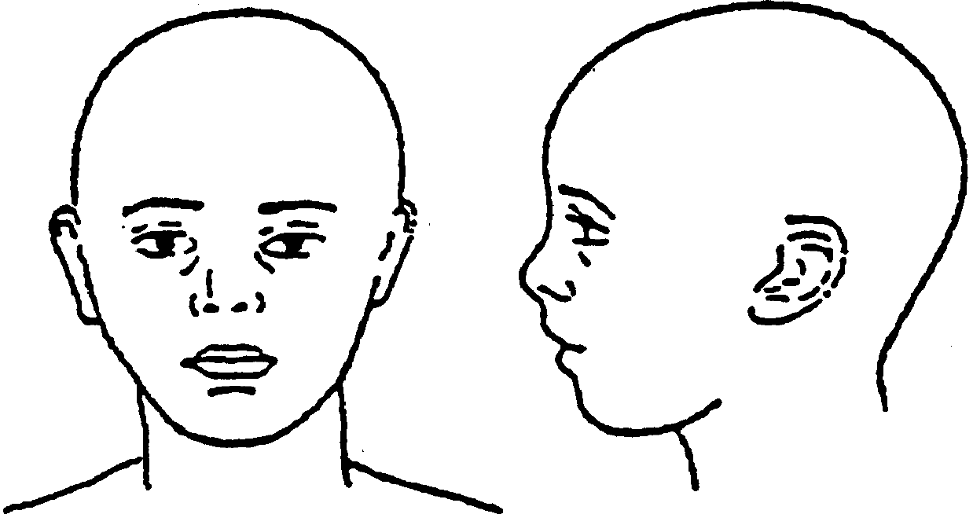
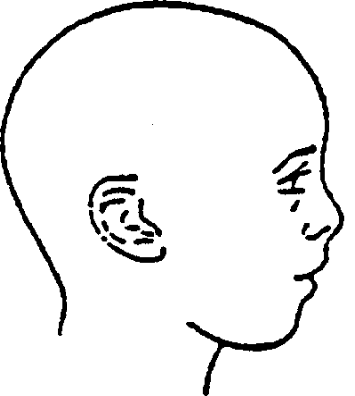
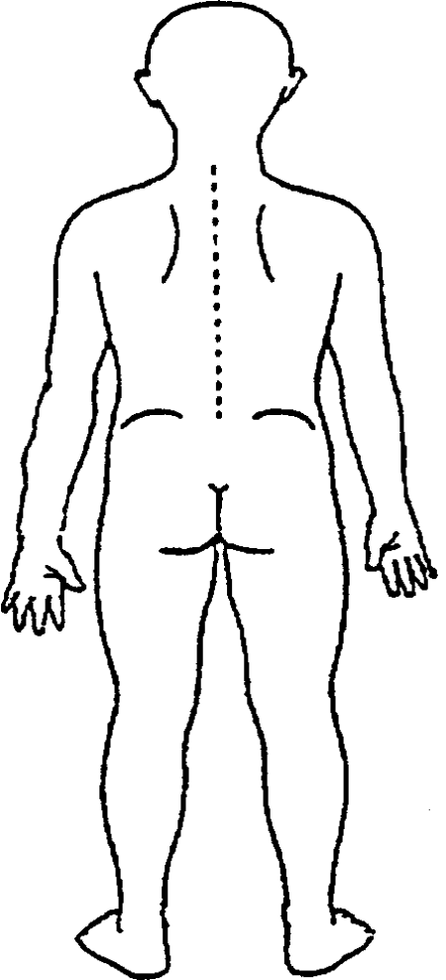
Electronic Version:
Click and move the red dot to indicate where the injury is located on the body/face.
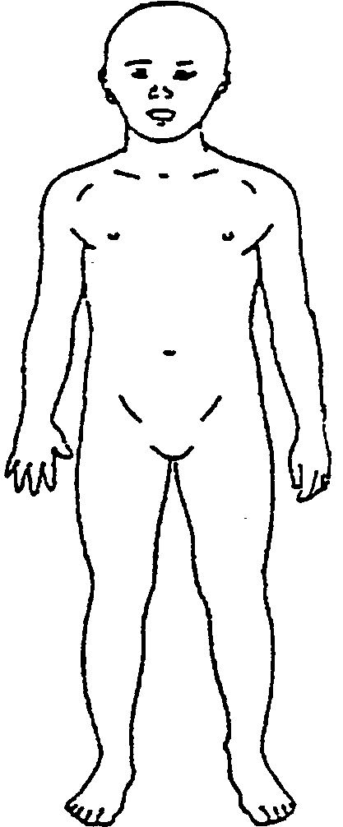

Appendix O – Designated Person Check List

Possible Action | By Whom | Outcome
Discuss with child
Contact parents
Check records in school
Discuss with relevant professionals
Check with schools who have siblings
Seek advice from LA
Monitor and review
Consider a CAF
Consult with Social Care
Contact Police
101: Non emergency
999: Immediate Danger
Other (please specify)
Assessment of Risk
Safeguarding | Risk of Harm | Immediate Danger

