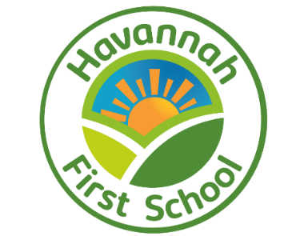

**Challenge, Equality & Opportunity**

**Art and Design**

**Whole School Curriculum Intent:**

|  |  |  |  |
| --- | --- | --- | --- |
| **We can build knowledge and skills** | **We are creative** | **We are resilient** | **We understand ourselves and each Other** |
| We strive for all of our children to have competency in the basic skills of reading, writing, maths and communication to underpin their learning, give them access to the broader curriculum and build their confidence as learners.  **pict0.jpg**We want our children to know more, remember more and be able to do more as a result of every learning experience across the curriculum. | **pict0.jpg**We want our children to be creative in their thinking so that they use their knowledge and skills to solve problems and create new knowledge, skills, thoughts and objects which give them enjoyment and inspire them to take their learning further. | We need our children to develop independence and resilience so that they are able to grow as thinkers and learners.  **pict0.jpg** | We aim for our children to develop empathy, awareness, respect and tolerance in-keeping with the school’s No Outsiders values.  **pict0.jpg**We also want all of our children to understand themselves and be ready for the next steps in their education and the wider world. |
| **What does this look like?** | | | |
| Achieve well in reading, writing and communication, including being at the age related expectation in early reading and phonics.  Can build on previous learning.  Can access new learning experiences.  Value and enjoy success in the core subjects.  Choose reading and use reading effectively.  Apply maths, reading, writing and communication across the curriculum. | Reflect, adapt and develop ideas.  Explore concepts.  Make links across the curriculum.  Ask questions and are curious.  Use initiative.  Hypothesise and generate ideas  Communicate learning.  Direct own learning through range of skills.  Can argue and use evidence. | Bounce back and try again.  Try new things and take risks.  Manage their own things, time and learning as appropriate.  Engage with extra-curricular activities.  Solve problems through perseverance.  Work towards a goal. | Listen to others.  Can work in a group and cooperate with others. Assess own success and learning.  Take turns and are patient.  Use manners and are polite in interactions with everyone.  Can manage emotions and support others.  Show respect.  Are kind and begin to show compassion.  Can follow the Golden Rules.  Can express themselves. |

**Art and Design Intent**

**We can build knowledge and skills**

Provide an art and design curriculum that provides the skills to develop a progressive knowledge and understanding of artistic techniques, processes and language.

Develop key skills in drawing, painting and craft as well as their understanding of the formal elements of colour, form, line, shape, pattern, texture and tone.

Develop knowledge of artists, movements, styles and crafts through reading, researching, visiting galleries and meeting artists and designers.

**We are Creative**

Make things!

Appreciate the value and purpose of art in a range of contexts.

Learn to express feelings and to communicate through art.

Try new ideas and techniques, combining materials and media for different affects and purposes.

**We are Resilient**

Ask questions and challenge their own views and thinking.

Adapt work as they go, making improvements and persevering to get to their desired outcome.

Make suggestions of how to create new images and objects and become increasingly independent in their selection and use of resources.

Be able to refine their work on the advice of others.

**We Understand Ourselves and Each Other**

Develop their understanding of their own and other cultures through studying a range of male and female artists and designers throughout history and from all around the world.

Work collaboratively to develop their research skills, develop communication and critical thinking skills.

Give children the language, experience and knowledge to evaluate their own work and the work of others.

Begin to understand the motivation of various artists, art styles, movements in various cultural heritages and different contexts.

Evaluate their own artwork and the work of others and express their likes and dislikes, making judgements and self-reflection.

**Art and Design Implementation**

We follow the online Kapow scheme which is continuously updated and developed primary art specialists. Videos for each lesson support-non specialists and ensure consistency between classes. All of the lessons can be easily adapted so that the same skills and knowledge can be built in different contexts.

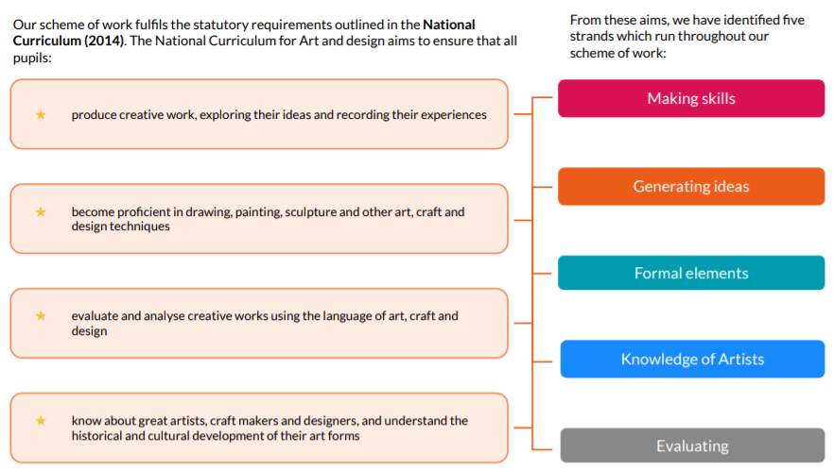

More information about the relationship between the curriculum and the school’s plans can be found in the Long Term Plan for Art.

**Progression in Art for Each Strand**

**Making Skills**

|  |  |  |  |  |  |
| --- | --- | --- | --- | --- | --- |
|  | **R** | **Year 1** | **Year 2** | **Year 3** | **Year 4** |
| **Making Skills** | | | | | |
| **Drawing** | Explore mark making with a variety of media in different contexts. | Explore mark making, experiment with drawing lines and use 2D shapes to draw. | Explore drawing techniques, begin to apply tone to describe form, develop skill and control with a range of drawing materials. | Develop drawing skills by drawing from direct observation, applying and using geometry and tonal shading when drawing. Use a range of drawing media. | Draw still life from observation and for mark making. Further develop understanding of geometry and mathematical proportion when drawing. |
| **Painting** | Use a variety of painting equipment to explore how paint works and the visual effects. | Develop skill and control when painting. Paint with expression. | Further improve skill and control when painting. Paint with creativity and expression. | Increase skill and control when painting. Apply greater expression and creativity to own paintings. | Develop skill and control when painting. Paint with expression. Analyse painting by artists. |
| **Craft, design, materials and techniques** | Use a variety of materials to create models and to know that lots of materials can be manipulated and used to make and create. | Learn a range of materials and techniques such as clay-etching, printing and collage. | Use a range of materials to design and make products including craft, weaving, printmaking, sculpture and clay. | Use materials such as paper weaving, tie dying, sewing and other craft skills to design and make products. | Make art from recycled materials, create sculptures, print and create using a range of materials. Learn how to display and present work. |
| **Knowing and applying the formal elements**  **COLOUR** | Remember and use the names of colours. Be able to choose colours, match colours and talk about the colours they use and like. | Remember the primary colours and how to mix them to create secondary colours. Create shades of a colour and choose and justify colours for purpose. | Mix, apply and refine colour mixing for purpose using wet and dry media. Describe their colour selections. | Increase awareness and understanding of mixing and applying colour, including use of natural pigments. Use aspects of colour such as tints and shades, for different purposes. | Analyse and describe colour and painting techniques in artists’ work. Manipulate colour for print. |
| **Knowing and applying the formal elements**  **FORM** | Explore different shapes and sizes of things which they create together or individually. | Learn about form and space through making sculptures and developing language. | Extend their practical ability to create 3D sculptural forms and begin to understand how to represent form when drawing. | Further develop their ability to describe 3D form in a range of materials, including drawing. | Develop their ability to describe and model form in 3D using a range of materials. Analyse and describe how artists use and apply form in their work. |
| **Knowing and applying the formal elements**  **LINE** | Use different media to draw using lines and explore different shapes and sizes created with lines. | Use, express and experiment with line for purpose, then use appropriate language to describe lines. | Draw lines with increased skill and confidence. Use line for expression when drawing portraits. | Express and describe organic and geometric forms through different types of line. | Learn and apply symmetry to draw accurate shapes. Analyse and describe how artists use line in their work. |
| **Knowing and applying the formal elements**  **PATTERN** | Explore patterns in the environment and use different media to make patterns. | Understand patterns in nature and in print, design and make patterns in a range of materials. | Learn a range of techniques to make repeating and nonrepeating patterns. Identify natural and man-made patterns. Create patterns of their own. | Construct a variety of patterns through craft methods. Further develop knowledge and understanding of pattern. | Create original designs for patterns using geometric repeating shapes. Analyse and describe how other artists use pattern. |
| **Knowing and applying the formal elements**  **SHAPE** | Choose shapes to make models and talk about shapes in the environment and in their own work. | Identify, describe and use shape for purpose. | Compose geometric designs by adapting the work of other artists to suit their own ideas. | Identify, draw and label shapes within images and objects. Create and form shapes from 3D materials | Create geometric compositions using mathematical shapes. Analyse and describe the use of shape in artist’s work. |
| **Knowing and applying the formal elements**  **TEXTURE** | Understand that different things feel different and talk about how things feel in their own work. | Use materials to create textures. | Identify and describe different textures. Select and use appropriate materials to create textures | Analyse and describe texture within artists’ work. | Use a range of materials to express complex textures. |
| **Knowing and applying the formal elements**  **TONE** | Talk about dark and light colours and dark and light in pictures. | Understand what tone is and how to apply this to their own work. | Experiment with pencils to create tone. Use tone to create form when drawing. | Develop skill and control when using tone. Learn and use simple shading rules | Use a variety of tones to create different effects. Understand tone in more depth to create 3D effects. Analyse and describe use of tone in artists’ work. |
| **Generating Ideas** | | | | | |
| **Sketchbooks** |  | To use sketchbooks through teacher modelling. Use sketchbooks to record thoughts and ideas and to experiment with materials | To use sketchbooks more effectively through further teacher modelling. Use sketchbooks to record thoughts and ideas and to experiment with materials | To use sketchbooks to generate ideas and record thoughts and observations. Make records of visual experiments. | Use sketchbooks for planning and refining work, to record observations and ideas and developing skill and technique. |
| **Creating Original Artworks** | Have many opportunities in continuous provision for creating art works. | Explore and create ideas for purposes and intentions. | Use artist sources to develop their own original artwork. Gaining inspiration for artwork from the natural world | Create personal artwork using the artwork of others to stimulate them. | Use literary sources to inspire art. Express thoughts and feelings through the tactile creation of art. Manipulate materials to achieve desired effects. Represent ideas from multiple perspectives. |
| **Knowledge** | | | | | |
| **Artists, craftspeople, designers** | **Study the work of the artists:** | **Study the work of the artists:** Beatrice Milhazes Bridget Riley David Hockney Vija Celmins Louis Wain Kandinsky Bernal Bolotowsky Vincent Van Gogh Jasper Johns Renoir Sorolla Kroyer Louise Bourgeois | **Study the work of the artists:** Max Ernst Frottage Ed Ruscha Clarice Cliff Nancy McCrosky Damien Hirst Julian Opie Edwina Bridgeman | **Study the work of the artists:** Carl Giles Diego Velazquez Prehistoric Artists  Puppet makers | **Study the work of the artists:** Luz Perez Ojeda Paul Cezanne Giorgio Morandi David Hockney Paula Rego Edward Hopper Pieter Brueghel Fiona Rae Giuseppe Archimboldo Sokari Douglas Camp El Anatsui Barbara Hepworth |
| **Evaluation** | | | | | |
| **Identify similarities and differences to others’ work** | Be able to talk about their work and the work of their peers. | Recognise and describe key features of their own and other’s work. | Compare other’s work, identifying similarities and differences. | Discuss own and other’s work using an increasingly sophisticated use of art language (formal elements). | Build a more complex vocabulary when discussing your own and others’ art. |
| **Reflecting** | Say what they like and don’t like.  Talk about the processes they have used. | Describe what they feel about their work and the art of others. | Describe choices and preferences using the language of art. | Reflecting on their own work in order to make improvements. | Use their own and other’s opinion of work to identify areas of improvement. |
| **Language** | | | | | |
| **Vocabulary** | Colour and colour names.  Names of common equipment used.  Bright, dark, straight, curved, messy, bumpy, smooth, shiny, big, small, pattern.  Painting, portrait, landscape, picture, print, sculpture, collage. | **Formal Elements Lessons:** Colour, line, pattern, tone, shape, form, tone, abstract art, composition, outlines, wavy, vertical, horizontal, crosshatch, primary and secondary colours.  **Sculpture & Collage Lessons:** Shells (exoskeletons) salt dough, plasticine, 3 dimensional, sculpture, natural materials carnivore, herbivore, omnivore, junk, creature.  **Landscapes Lessons:** Shoreline, horizon, up, down, straight, left, right, texture, tints, shades, light, dark, landscape.  **Art & Design Skills Lessons:** Geometry, Tudor, Great Fire of London, printmaking. | **Formal Elements Lessons:** Colour, line, pattern, tone, shape, form, tone, Jupiter, shading, three-dimensional, rubbings, frottage, tear, experiment, design, repeat pattern.  **Art & Design Skills Lessons:** Rollercoaster, free-flowing, precise, straight, curved, edge, design, concentric, silhouette, weaving, horizontal, vertical, template, overlay, vessel, slip, clay.  **Human Form Lessons:** Detail, modelling, facial features, outline, contours, collage, beauty, skull, decorate, proportion, pose, collaborate.  **Sculpture & Mixed Media Lessons:** Pastel, blend, shadow, paint wash, background, scale, explosion, action words, expression, mannequin. | **Formal Elements Lessons:** Colour, line, pattern, tone, shape, form, tone, shading, shading grip, wire techniques, bending, shaping, geometry, 3D, sketch.  **Art & Design Skills:** Puppet, shadowpuppet, decorate, detail, observation, tint, shade, light and dark.  **Prehistoric Art:** Negative, positive, tints, shades, natural form names, charcoal, scaling, texture, fixative.  **Craft:** Running stitch, fabric, weave, over-and-under, woven, reverse, warp, weft, tie-dying, wax resist, mood board. | **Formal Elements Lessons:** Colour, line, tone, form, shape, pattern, texture, symmetrical, mark making.  **Sculpture Lessons:** Stomp, rhomboid, maracas, pitch, collage, recycled, geometric, contrasting, memorial.  **Art and Design Skills Lessons:** Curator, montage, carving, modelling, casting, constructing, pierced form, upright form, chinoiseries, op-art. |

Art is taught as part of the continuous provision and as discrete lessons in Reception. In KS 1 and 2, there are four units for each year group, each unit consists of 5 or 6 lessons which are usually taught discretely. It can be taught weekly across four half terms or some units can be delivered on an art focus day or across several afternoons. We have built in flexibility to ensure that art is not ‘squeezed’ out of the busy curriculum.

Please see Long Term Plan for Art for more information.

Art is not usually planned to match other topics in the curriculum but the units can be adapted, Teachers meet with the art lead to discuss this and ensure that any adaptations still include coverage of the five strands.

**A Typical Art Lesson at Havannah First School**

**Each KS1 and 2 lesson typically follows the following format:**

1. Fast recall of the previous lesson’s content (skills, techniques, knowledge)
2. Attention Grabber

The children will look at the work of an artist or designer and there will be discussion around what can be seen with relation to what the children are learning in the lesson.

This will be the form of images, objects or a video.

1. Teacher demonstration or video of the skill/technique being taught in the lesson.
2. Children practising and exploring as they apply their learning to make their own images and objects with support and frequent opportunities to evaluate and refine their work.
3. Evaluation and celebration of work, comparing their own work to that of other artists and a discussion of what next.

Lesson structures can vary to suit the content and the objective.

Children will work indoors and sometimes outdoors.

Children access and select their own resources when possible.

Sketchbooks are used to capture ideas and work throughout the units.

Vocabulary is built upon and used in each lesson.

Children will make a visit to a local gallery or exhibition at least once in KS1 and in KS2.

<https://laingartgallery.org.uk/>

<https://hattongallery.org.uk/>

<https://shipleyartgallery.org.uk/>

<https://www.thebiscuitfactory.com/>

<https://www.jimedwardspaintings.com/>

<https://baltic.art/>

<https://newcastlegateshead.com/business-directory/things-to-do/angel-of-the-north>

<https://www.sevenstories.org.uk/>

<https://southshieldsmuseum.org.uk/>

